

Year 6 Homework Menu Summer Term A
Please complete a minimum of two tasks.

Food D&T:  Design a healthy breakfast with seasonal  foods that will make your brain work better. | Art:  Create your own comic. |  | Online Safety:  Explain how to create a secure password.
Science:  Keep a Moon diary for the month, drawing a picture  of the phase of the Moon each day. | History:  Create an artistic timeline of British history. |  | School Value:  Create a short play explaining why it is important to be honest.
RRSA – Articles 6 & 24: Do something special for Earth Day |  | Activity Passport: Learn to knit.

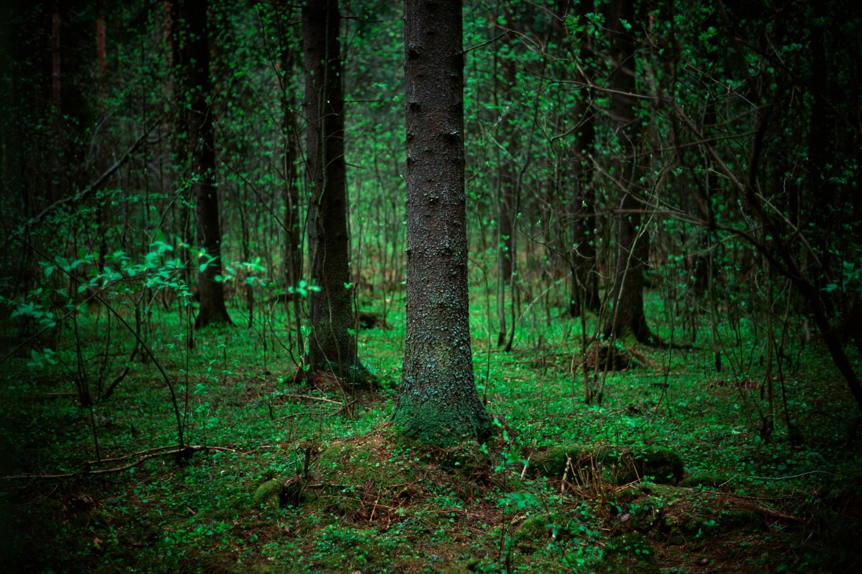

Year 6 Homework Menu Summer Term B
Please complete a minimum of two tasks.

PSHE:  Run a small business stall at the Summer Fete | Art:  Paint a self-portrait. |  | Online Safety:  Explain to someone what scams and phishing are.
Science:  Make a 2-minute experiment to bring in and demonstrate to people. | History:  Research the Moon landings. |  | School Value:  Do something courageous – surprise us!
RRSA – Article 31:  Audition for the production. |  | Activity Passport:  Choose objects that you could put in a time capsule.

