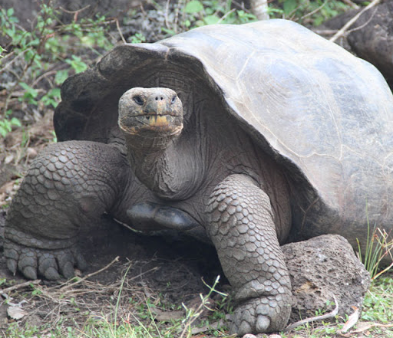

Year 6 Homework Menu
Spring Term A
Please complete a minimum of two tasks.

Science:  Go fossil hunting | Geography:  Make a PowerPoint presentation about a country in South America giving key facts about it. |  | Online Safety:  Research how to report inappropriate content on all the apps, websites and devices you regularly use.
Computing:  Make a comic or flow chart showing how the Internet works. | RE:  Research a Christian charity |  | School Value:  Create a guide to how to be a respectful person.
Activity Passport:  Organise tea for your parents/carers. |  | Rights Respecting Schools Award:  Article 16: Teach somebody how to keep their information safe online
The Great Languages Challenge:
Find out the nationalities of the players in your favourite sports team.

