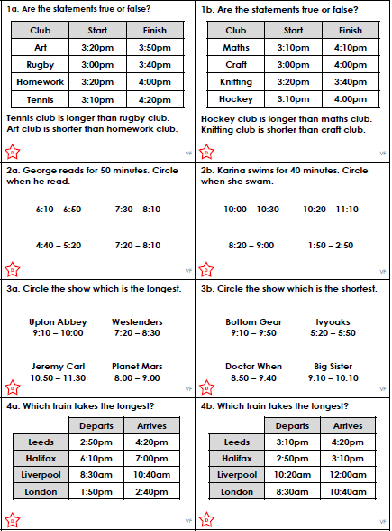

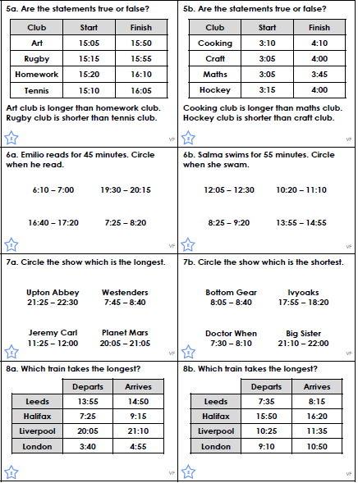

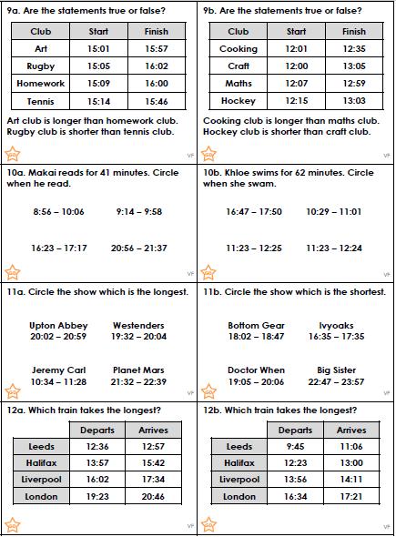
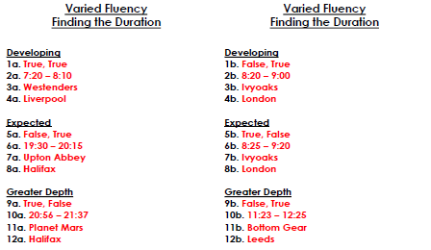

Who or Which?
We are learning to join sentences together using who or which.

For example: I have a cousin. My cousin lives in Australia.
Will become: I have a cousin who lives in Australia.

For example: I received a letter. The letter came from London.
Will become: I received a letter which came from London.

Rewrite these sentences using who or which.

Harry bought a football. The football was red and white.

Peter has two friends. The friends are named James and John.

I lost the pen. The pen was a gift from my brother.

Mrs Knutt is reading a book. The book is very good!

We helped the old man. The old man had hurt his leg.

We have a new car. The new car is red.

I am going to visit my uncle. My uncle lives on a farm.

