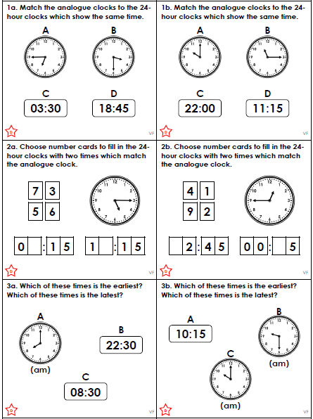

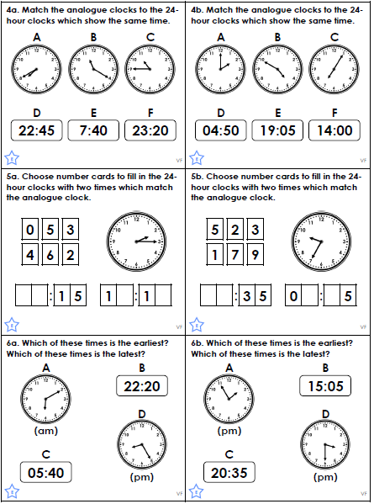
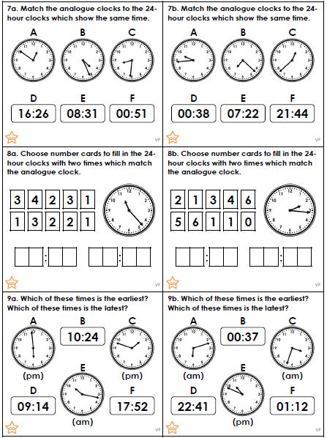
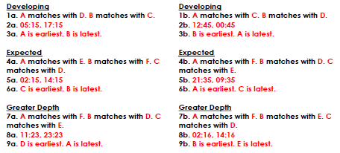

Please select a short poem to perform in class. It does not have to be learnt by heart.

Performing a poem requires focus and practice, but there are things you can do that help:
- Think about the story the poem is telling.
- Focus on the rhythm of the poem.
- Look at the rhyming words used in the poem.
- Think of actions or images that could go with each line.

Top tip!
- Remember to take your time and keep practising – it takes time and focus!

This is one of Mrs Knutt’s favourite poems:

The Big Race
There’s a rapid rushing rabbit
Running round the racing track
With a rattlesnake behind him
And a raven on his back,
And the reindeer’s been disqualified
For wearing roller skates
And the reptile didn’t even start
As he arrived too late.

They round the bend,
They raise some dust,
The crowd’s roar raises rafters.
A raccoon trips upon a rock,
A reed frog falls soon after,
A robin flies above the race,
A rook brings up the rear,
In a rising cloud of dust a rhino disappears.

They reach the final stretch of track,
The rabbit wins the gold,
The rhino comes in second
But he blames it on his cold.

