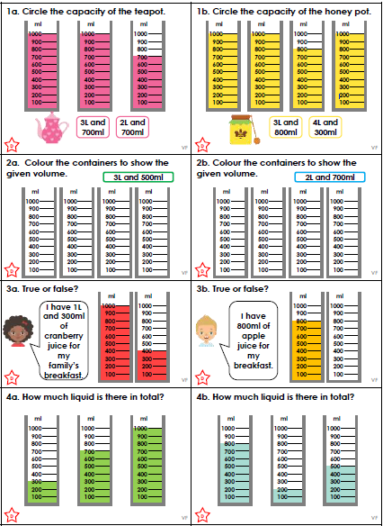
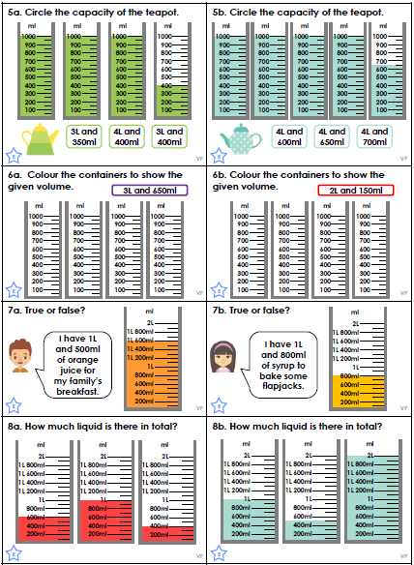
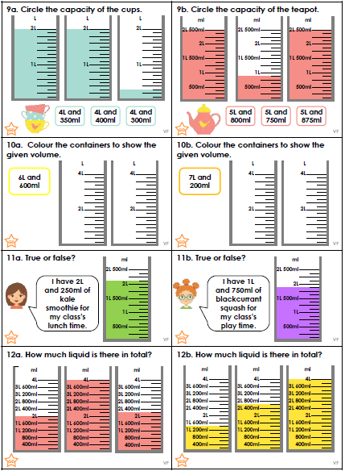
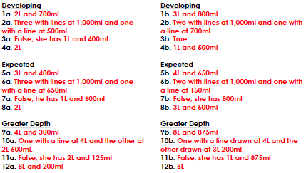
We have been writing Show, Not Tell sentences to improve our writing.
Using the emotion shown here, write a sentence which shows us the feeling without telling us. Look back at last week’s homework to give you some ideas.
ill | 
disgusted | 
relieved | 
brave | 
strong | 

These are some of Mrs Knutt’s ideas:

- The boy rubbed his aching head with his hand and sneezed loudly.
- He turned away from the smell and held his nose. He left the room immediately – he couldn’t stand to be there any longer.
- They held each other tightly. The waiting for news had been painful but now she was safe.
- Ignoring his jittery stomach, the boy hopped into the harness and braced himself. “I can do this,” he said to himself as he jumped off the platform.
- Every muscle in his body contracted before he lifted the heavy tyre. It would normally take two men to move it!

