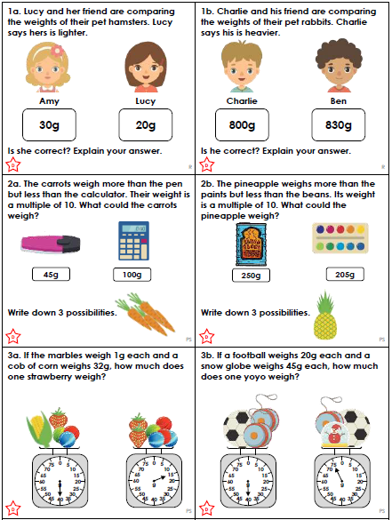

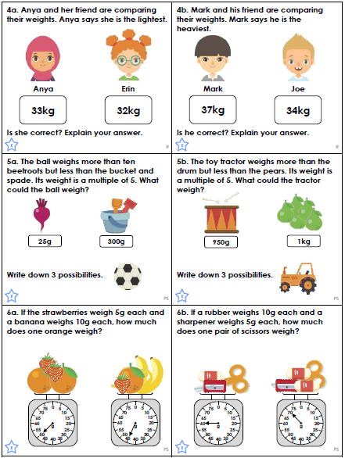

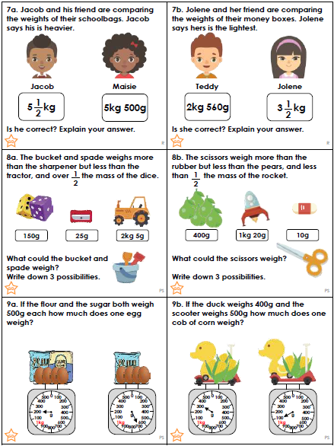
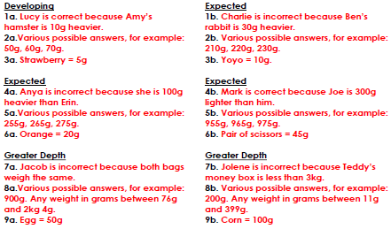
We have been thinking about emotions to improve our writing.
These sentences are show, not tell sentences. Which emotions are being shown but not told in these examples?
With trembling hands and a racing heart, the boy reached out in the dark to open the door.
Blushing crimson, the girl looked at the ground as she tried to fight back the tears. She had made a complete fool of herself.
The butterflies in his stomach were doing somersaults as he waited to go on stage to perform his song to the ever-growing audience.
The man clenched his fist behind his back and the vein in his neck bulged as his manager walked away without an explanation.
Slouching in his chair, the boy yawned loudly and rubbed his eyes.
The bride stood with her heart pounding and a huge smile across her face as she said to the man she loved with all her heart, “I do!”
The child punched the air and did a celebratory dance as he scored the first goal of the season.
The boy scratched his head, wrinkled his forehead into a frown and reread the maths question. What was he supposed to do now?

hot | happy | confused | cold | nervous
excited | angry | tired | embarrassed | shy

