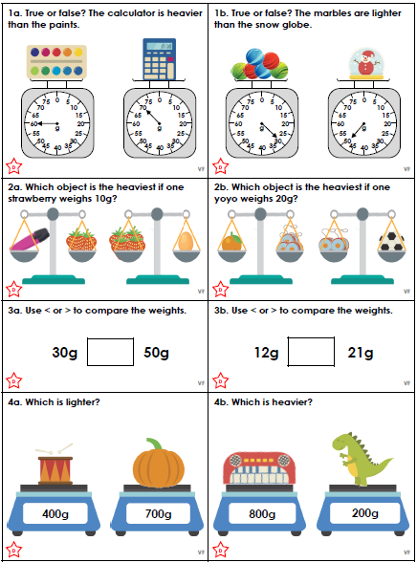
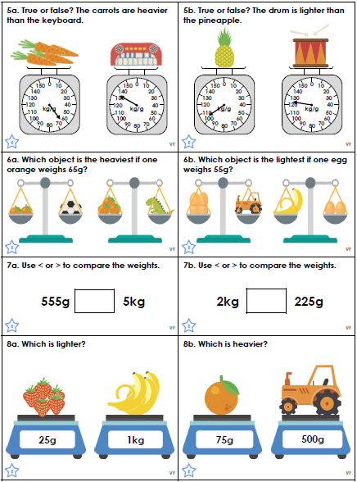
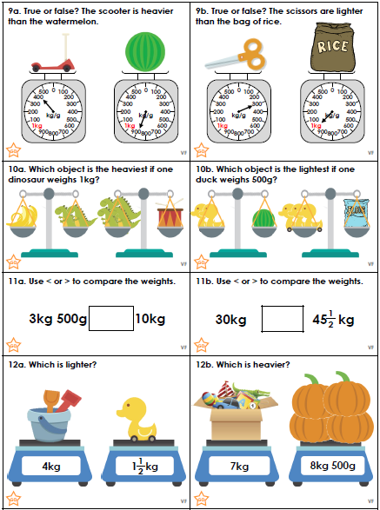

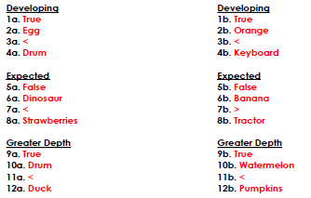
Subordinating Conjunctions

List the subordinating conjunctions using this acronym:
I |  | W
S |  | A
A |  | B
W |  | U
A |  | B

Now identify the subordinating conjunction in each sentence below:

- The flat burned down because the electrics hadn’t been checked.
- After they finished their homework, Steven and his friends played football.
- The wind danced around the trees before it rained.
- Tom saw the maid when she came through the door.
- While looking through the window, Sophie saw the BFG.
- If you eat all your dinner, you can have an ice cream.
- Ryan got a prize although he was last in the race.
- On his birthday Adam wanted a football until he saw a baseball.
- As he was angry, Steven kicked the boy next to him.
- Adam crept up the stairs since he was late and would get into trouble.

Write 3 sentences of your choice using 3 different subordinating conjunctions.

Subordinating Conjunctions

List the subordinating conjunctions using this acronym:
I |  | W
S |  | A
A |  | B
W |  | U
A |  | B

Now identify the subordinating conjunction in each sentence below:

- The flat burned down because the electrics hadn’t been checked.
- After they finished their homework, Steven and his friends played football.
- The wind danced around the trees before it rained.
- Tom saw the maid when she came through the door.
- While looking through the window, Sophie saw the BFG.
- If you eat all your dinner, you can have an ice cream.
- Ryan got a prize although he was last in the race.
- On his birthday Adam wanted a football until he saw a baseball.
- As he was angry, Steven kicked the boy next to him.
- Adam crept up the stairs since he was late and would get into trouble.

