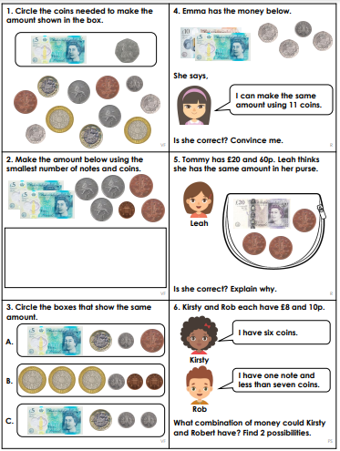

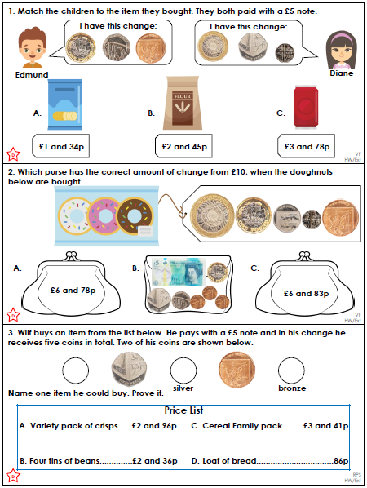

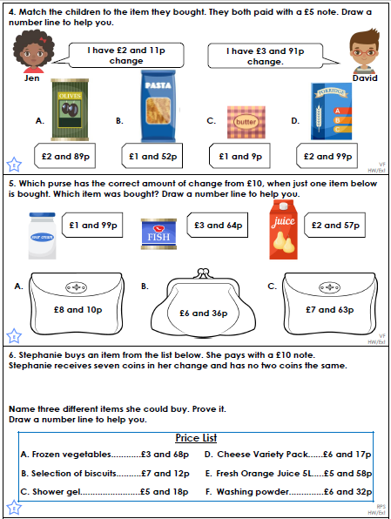

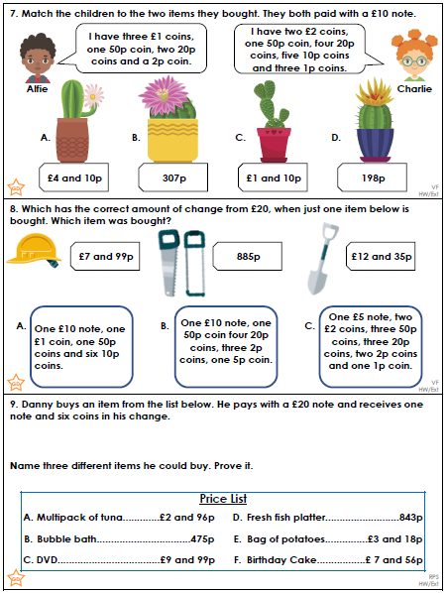

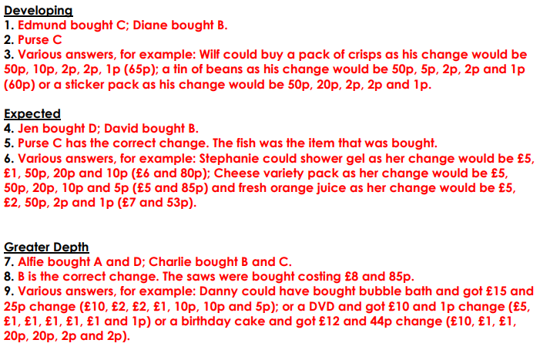

Make plurals of these nouns: Use the box to help you:

baby |  | 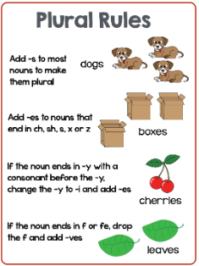

lady

penny

pastry

pony

bush

dress

church

fox

bus

dog

cat

table

pen

chair

Make plurals of these nouns: Use the box to help you:

lady

penny

pastry

dictionary

bush

dress

church
fox |  | man
bus |  | mouse
buzz |  | foot
dog |  | child
cat |  | shelf
table |  | wolf
potato |  | knife
tomato |  | scarf

