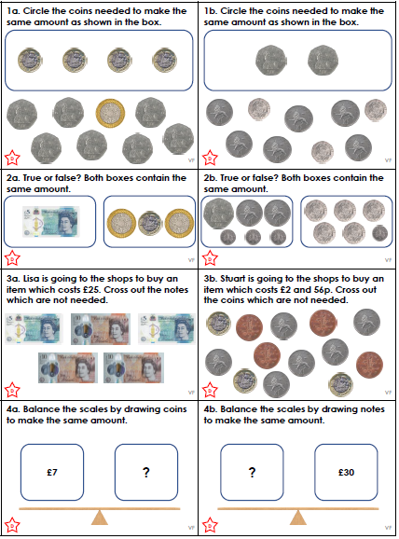
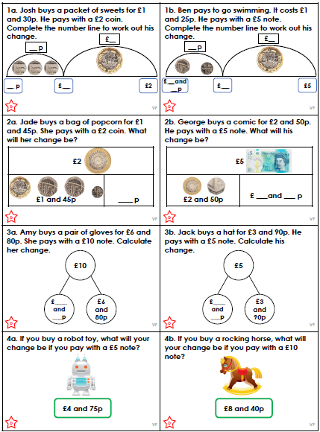
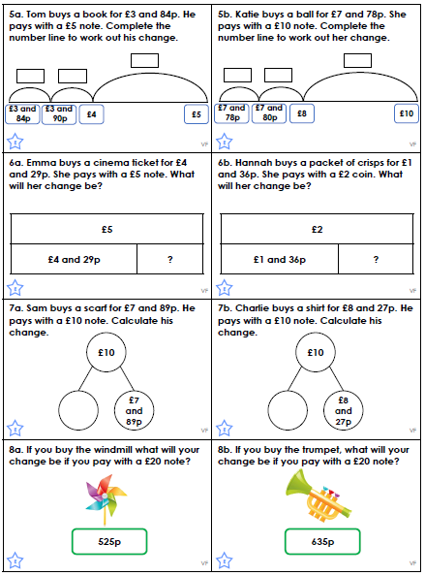
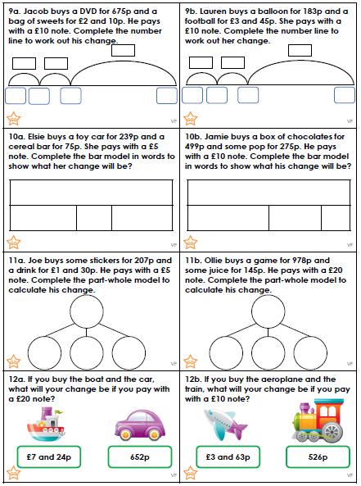

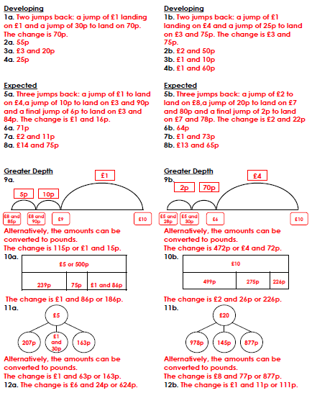

Statements - Statements are sentences which tell you something. They end with a full stop.

Questions - Questions are sentences that ask you something. They usually end with a question mark.

Commands - Commands are sentences that tell you to do something. They are often urgent or angry and can be very short.

Exclamations - Exclamations are sentences that begin with ‘what’ or ‘how’. They are full sentences, include a verb and end with an exclamation mark.

Underline each sentence in the correct colour.

- Is it cold outside?
- How kind of him to do that!
- “Finish your writing,” said the teacher.
- It is great fun going to the park.
- A puppy will grow up to be a dog.
- Should you really eat 7 chocolate bars?
- Turn the television off.
- Tim and Tom went to play in the park.
- What a lot of people there are today!
- Do you want to go on the swings now?
- My bicycle is red.
- “What a nice young man!” shouted Anne.
- Tidy your room.
- Have you finished your homework?
- How exciting!
- Put your shoes on.
Statements - Statements are sentences which tell you something. They end with a full stop.

Questions - Questions are sentences that ask you something. They usually end with a question mark.

Commands - Commands are sentences that tell you to do something. They are often urgent or angry and can be very short.

Exclamations - Exclamations are sentences that begin with ‘what’ or ‘how’. They are full sentences, include a verb and end with an exclamation mark.



