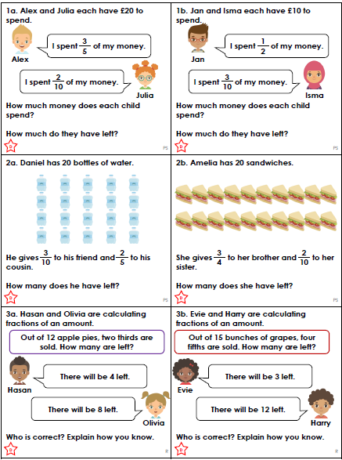

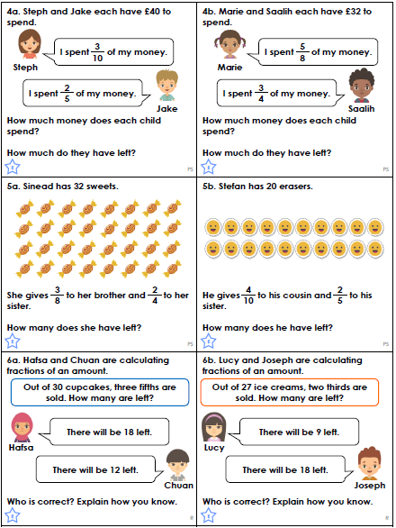
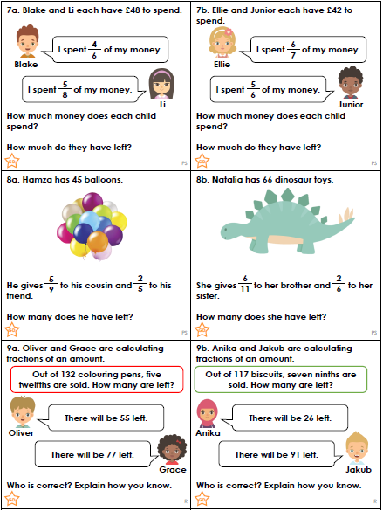
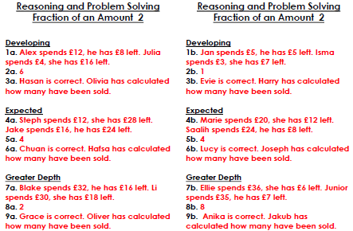
We are consolidating our use of apostrophes for contractions.
Put in the missing apostrophes:

“I dont want peas,” said Lucy.
“Youll get hurt,” warned Granny.
“Its going to snow today,” said the man.
“Were not going until Monday,” announced Mum.
“Ill post the letter this afternoon,” said Dad.

Use these words in sentences of your own.
can’t she’ll we’ve haven’t

We are consolidating our use of apostrophes for contractions.
Put in the missing apostrophes:

“I dont want sandwiches,” said Lucy.
“You mustnt play near the road,” warned the teacher.
“Its going to snow today,” said the weather man.
“Were not going until tomorrow,” announced Mum.
“Well post the letter this afternoon,” said Dad.

Use these words in sentences of your own.
can’t she’ll we’ve haven’t

We are consolidating our use of apostrophes for contractions.
Put in the missing apostrophes:

“I would like sandwiches,” said Lucy.
“You mustve left it at school,” warned the teacher.
“It isnt going to snow today,” said the weather man.
“Werent you going after school?” asked Mum.
“Well post the letter this afternoon,” said Dad.
“We havent got all day,” said Rob.

Use these words in sentences of your own - shouldn’t won’t we’ve couldn’t

