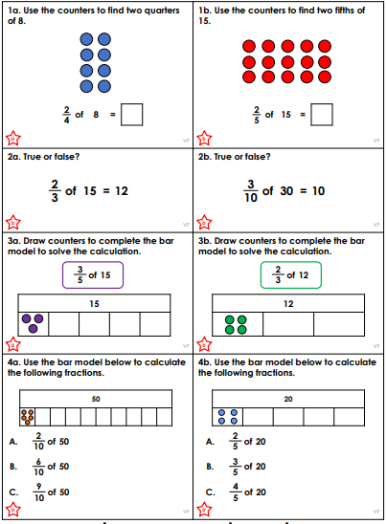

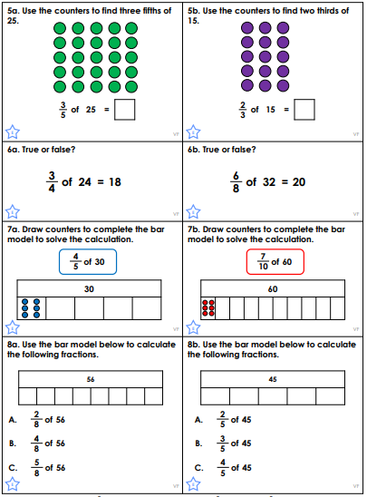

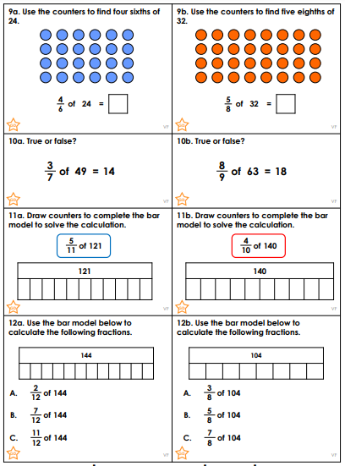

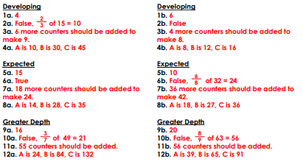
We are learning how to write speech which is correctly punctuated and formatted.
We used the “Speech Sandwich” method …

Bread | Filling | Sauce | Bread | Reporting  clause
“ | Are you okay | ? | ” | asked the bird.

- Open speech marks " (bread)
- Write what the person is saying (filling)
- Include punctuation , ? . ! (sauce)
- Close the speech " (bread)
- Add a word for said (whispered, shouted)
- Report who said it - Tim, Tom
- Full stop.

Please write out these sentences with the correct punctuation:
Number 8 is split speech. Have a go to see if you remember how to do it …

1 | Do you know where I put my book asked Claire.
2 | We will read after lunch said Mr Jones.
3 | Can you help me asked Greg.
4 | I can’t find my homework moaned Sally.
5 | What do you want snapped the old lady.
6 | I enjoyed going swimming said Tim.
We are learning how to write speech which is correctly punctuated and formatted.
We used the “Speech Sandwich” method …

Bread | Filling | Sauce | Bread | Reporting  clause
“ | Are you okay | ? | ” | asked the bird.

- Open speech marks " (bread)
- Write what the person is saying (filling)
- Include punctuation , ? . ! (sauce)
- Close the speech " (bread)
- Add a word for said (whispered, shouted)
- Report who said it - Tim, Tom
- Full stop.

Please write out these sentences with the correct punctuation:

1 | Do you know where I put my book asked Claire.
2 | Someone has kicked a ball through my window shouted Mrs Hart.
3 | We will do silent reading after lunch said Mr Jones.
4 | Can you help me enquired Greg.
5 | What do you want snapped the old lady.
6 | I can’t find my homework moaned Sally.
7 | I enjoyed going swimming said Tim.
8 | Don’t be late again warned the teacher.
We are learning how to write speech which is correctly punctuated and formatted.
We used the “Speech Sandwich” method …

Bread | Filling | Sauce | Bread | Reporting  clause
“ | Are you okay | ? | ” | asked the bird.

- Open speech marks " (bread)
- Write what the person is saying (filling)
- Include punctuation , ? . ! (sauce)
- Close the speech " (bread)
- Add a word for said (whispered, shouted)
- Report who said it - Tim, Tom
- Full stop.

Please write out these sentences with the correct punctuation and change the words from said:
Number 8 is split speech. Have a go to see if you remember how to do it …

1 | Do you know where I put my book said Claire.
2 | Someone has kicked a ball through my window said Mrs Hart.
3 | We will do silent reading after lunch said Mr Jones.
4 | Can you help me said Greg.
5 | What do you want said the old lady.
6 | I can’t find my homework said Sally.
7 | I enjoyed going swimming said Tim.
8 | Don’t be late again said the teacher. Or it will mean detention for you!

