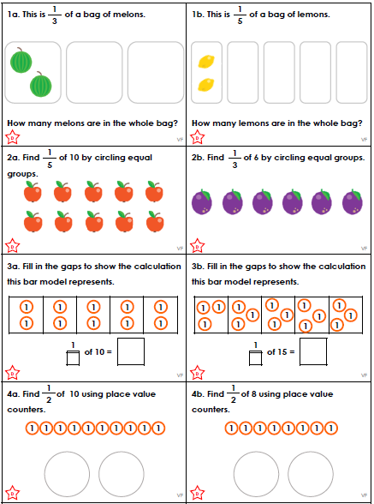

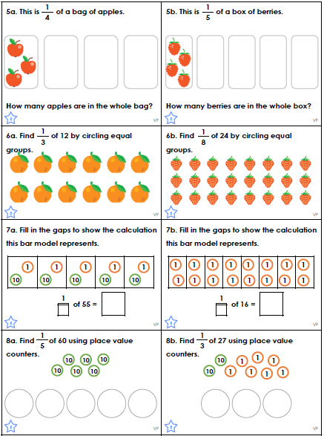

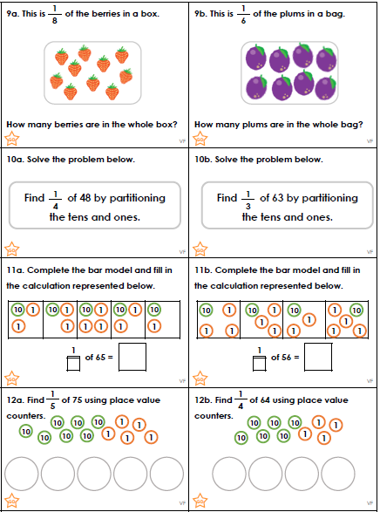

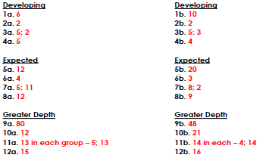
We are learning how to deduce and infer from a text. This is where the text does not explictly give the answer. You have to read around the text and “between the lines” to get the clues!
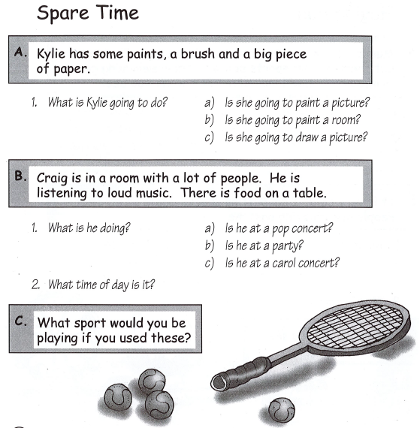
We are learning how to deduce and infer from a text. This is where the text does not explictly give the answer. You have to read around the text and “between the lines” to get the clues!
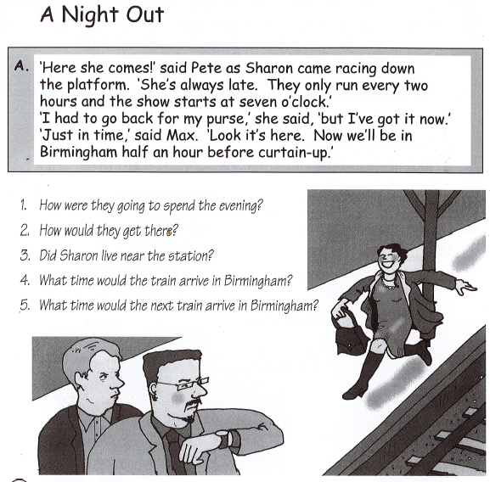

We are learning how to deduce and infer from a text. This is where the text does not explictly give the answer. You have to read around the text and “between the lines” to get the clues!


