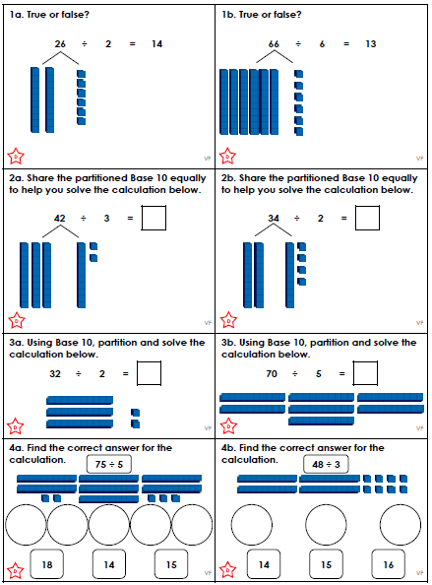
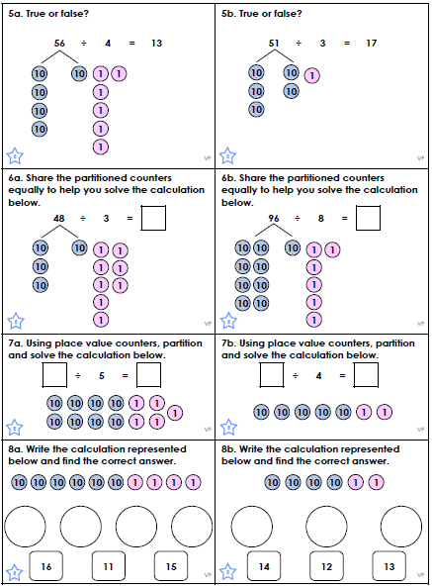
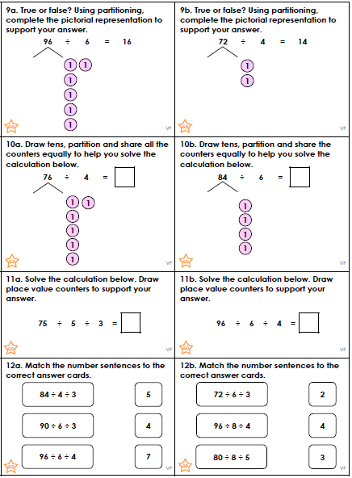

How does the land use affect the jobs in our local area?
As part of our Geography Unit on Land Use, we are investigating the jobs which people do in our local area. Please ask 15 people – they can be your family or neighbours – which sector they fall into and make a tally.
We will create a bar chart from our individual findings. Happy investigating!
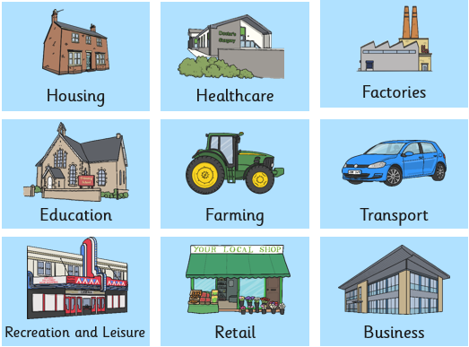
Any other sector

