We have been using our times table knowledge to calculate word problems.

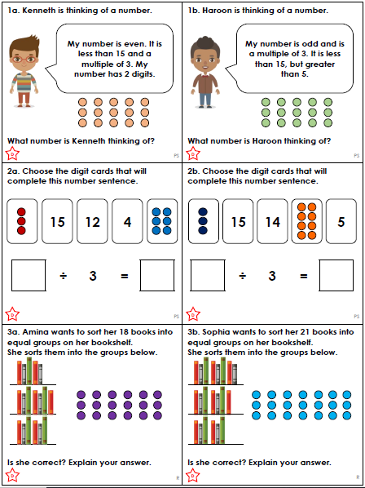

We have been using our times table knowledge to calculate word problems.

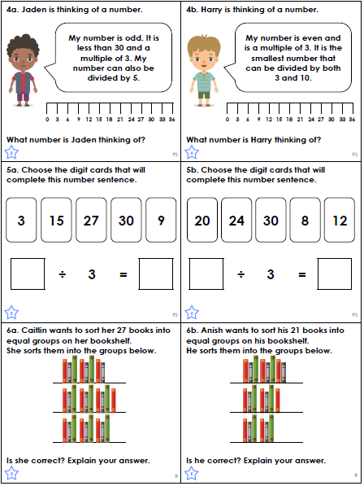

We have been using our times table knowledge to calculate word problems.

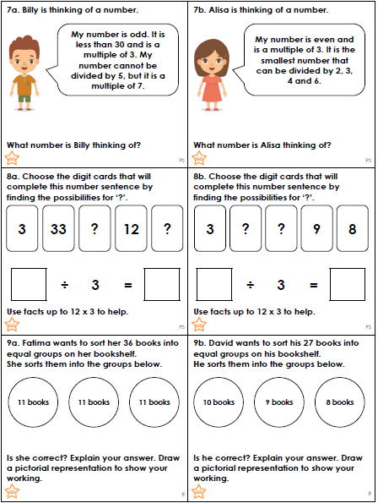

This week we have been looking at how to use different prefixes and suffixes.
Please complete this table …
Prefix | Meaning | Example | Write down 1 more example of a word with this prefix
un | usually means not | unable
re | again | retell
mis | wrong or false | misunderstand
dis | opposite of | disloyal
auto | self or same | automatic
sub | beneath/below | submarine
pre | before | preheated

Please complete this table …
Suffix | Meaning | Example | Write down 1 more example of a word with this suffix
ful | full of | joyful
est | most | tallest
ing | doing now | cycling
less | without | fearless
ly | how something was done | quickly
er | more (adjective) | taller
er | someone’s job | teacher

