As it is assessment week next week, we are looking at the style of some of the reasoning questions which may pop up.
- 2 tens + 3 ones =
- 3 tens + 4 ones =
- There are 30 children at the school fair. 17 of them are girls. How many are boys?
- Pencils are packed in groups of 5. How many pencils are there if there are 8 groups?
- + + + + = 40
- + + + + = 25
- + + + + = 15
- + + =
- Liz has 200 marbles.
Jim has 80 less than Liz.
Jim wants 300 marbles. How many more does he need?
- Cakes are in packs of 4 and I have bought 4 packs. How many cakes are there altogether?
As it is assessment week next week, we are looking at the style of some of the reasoning questions which may pop up.
- 6 tens + 8 ones =
- 5 tens + 9 ones =
- There are 120 children at the school fair. 70 of them are girls. How many are boys?
- Pencils are packed in groups of 8. How many pencils are there if there are 6 groups?
- + + + = 32
- + + = 15
- + + + = 12
- + + =
- Liz has 276 marbles.
Jim has 64 less than Liz.
Jim wants 300 marbles. How many more does he need?
- Cakes are in packs of 3 and I have bought 9 packs. How many cakes are there altogether?
As it is assessment week next week, we are looking at the style of some of the reasoning questions which may pop up.
- 2 hundreds, 6 tens + 8 ones =
- 7 hundreds, 5 tens + 9 ones =
- There are 167 children at the school fair. 84 of them are girls. How many are boys?
- Pencils are packed in groups of 8. How many pencils are there if there are 20 groups?
- + + + = 32
- + + = 15
- + + + = 12
- + + =
- Liz has 226 marbles.
Jim has 87 less than Liz.
Jim wants 300 marbles. How many more does he need?
- Cakes are in packs of 3 and I have bought 90 packs. How many cakes are there altogether?
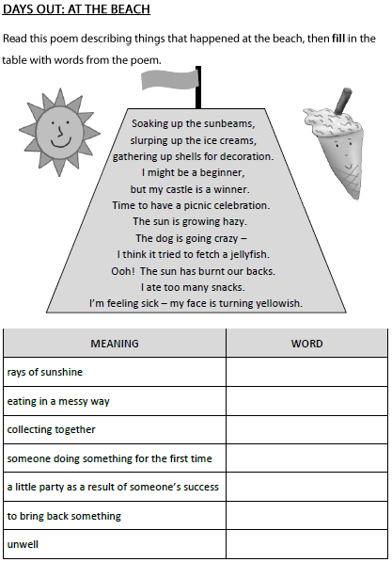
Meaning | Word
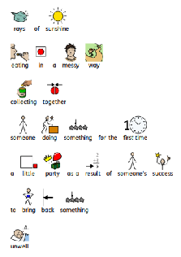
Days Out: At The Beach.

Read this poem describing things that happened at the beach, then fill in the table with words from the poem.



