Rounding to the Nearest 10
Look at the ones digit.
- if it is less than 5 then round the number down by changing the ones digit to zero;
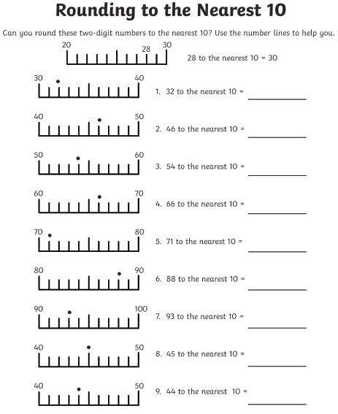
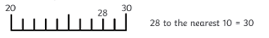
- if it is 5 or more then round the number up by adding one on to the tens digit and changing the ones digit to zero.

Rounding to the Nearest 100
Look at the tens digit.
- if it is less than 5 then round the number down by changing the tens digit to zero;
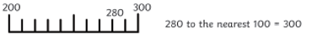
- if it is 5 or more then round the number up by adding one on to the hundreds digit and changing the tens digit to zero.
- The ones digit will also change to zero.
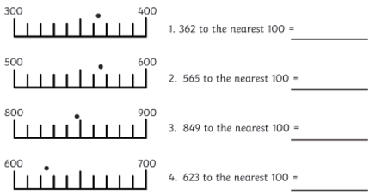

Rounding to the Nearest 10
Look at the ones digit.
- if it is less than 5 then round the number down by changing the ones digit to zero;
- if it is 5 or more then round the number up by adding one on to the tens digit and changing the ones digit to zero.
Rounding to the Nearest 100
Look at the tens digit.
- if it is less than 5 then round the number down by changing the tens digit to zero;
- if it is 5 or more then round the number up by adding one on to the hundreds digit and changing the tens digit to zero.
- The ones digit will also change to zero.
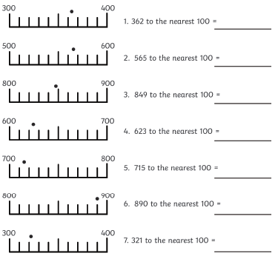

Change these sentences to present tense:
The dog barked loudly.
The dog _______________ loudly.

Yesterday, the sun rose in the sky.
Today, the sun _______________ in the sky.

There was a big giant that lived in the cave.
There __________ a big giant that __________ in the cave.

The bird swooped down from the tree tops.
The bird _______________ down from the tree tops.

Change these sentences to past tense:
There are two birds on the fence..
There __________ two birds on the fence.

She takes some drinks to the party.
Last week, she _______________ some drinks to the party.

Rob is jumping over the wall.
Yesterday, Rob ________________ over the wall.

Tomorrow, I am driving my car to Taunton.
Last weekend, I _______________ my car to Taunton.



