We have been learning how to add 9 and 11 to numbers. Look at the number lines below and add the two numbers together using the number line.

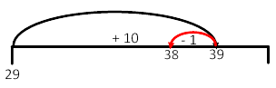  Adding 9 is the same as adding 10 then taking away 1 | Adding 11 is the same as adding 10 and adding 1  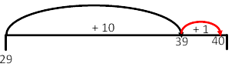

23 + 9 = | 
55 + 9 =
78 + 9 =
81 + 9 =
36 + 11 =
62 + 11 =
44 + 11 =
89 + 11 =

We have been learning how to add 9 and 11 to numbers. Look at the number lines below and add the two numbers together using the number line.

Adding 9 is the same as adding 10 then taking away 1 | Adding 11 is the same as adding 10 and adding 1

87 + 9 =
398 + 9 =
Can you add 19 by adding 20 and taking away 1?
76 + 19 =
Can you add 19 by adding 20 and taking away 1?
823 + 19 =
62 + 11 =
293 + 11 =
Can you add 21 by adding 20 and adding 1?
267 + 21 =
Can you add 21 by adding 20 and adding 1?
305 + 21 =

We have been learning how to add 9 and 11 to numbers. Look at the number lines below and add the two numbers together using the number line.

Adding 9 is the same as adding 10 then taking away 1 | Adding 11 is the same as adding 10 and adding 1

98 + 9 =
395 + 9 =
Can you add 19 by adding 20 and taking away 1?
86 + 19 =
Can you add 19 by adding 20 and taking away 1?
628 + 19 =
89 + 11 =
493 + 11 =
Can you add 21 by adding 20 and adding 1?
287 + 21 =
Can you add 21 by adding 20 and adding 1?
385 + 21 =

We have been consolidating our grammar knowledge. Please work your way through these questions:


