Look at these calculations … Are they correct? Prove it by showing your working out! 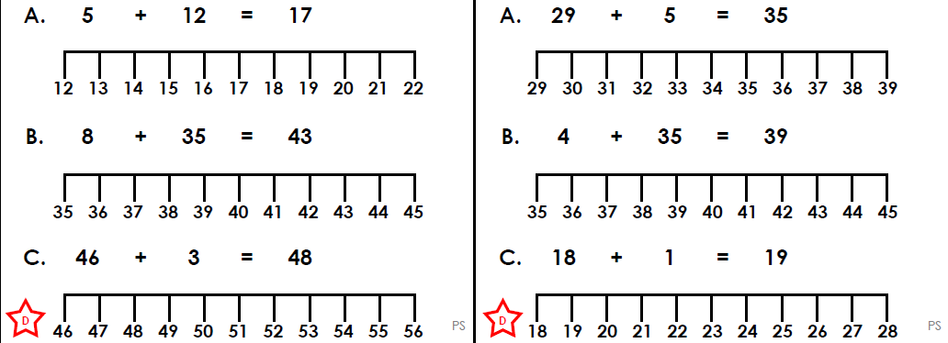

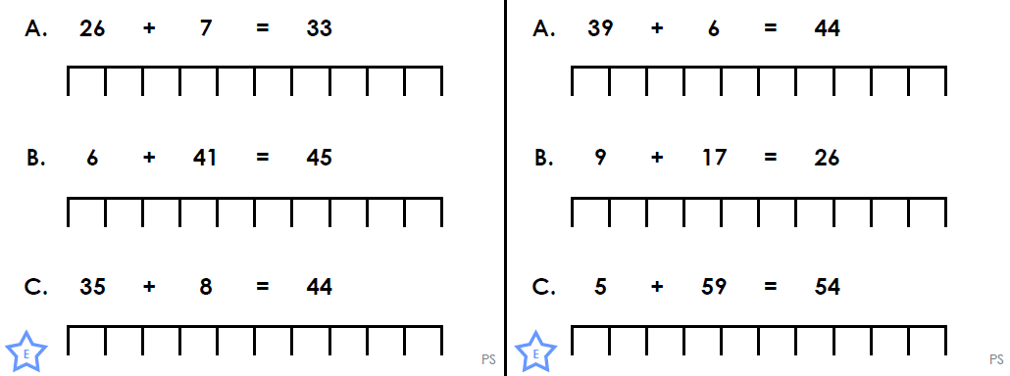

Use these number line to subtract 7 from 48. Use this number line to subtract 6 from 27.

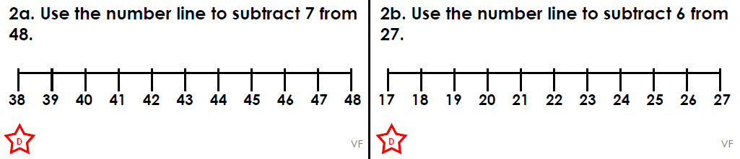

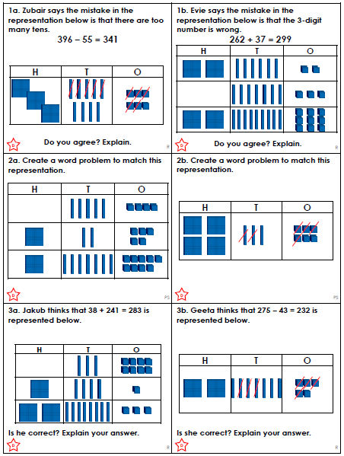
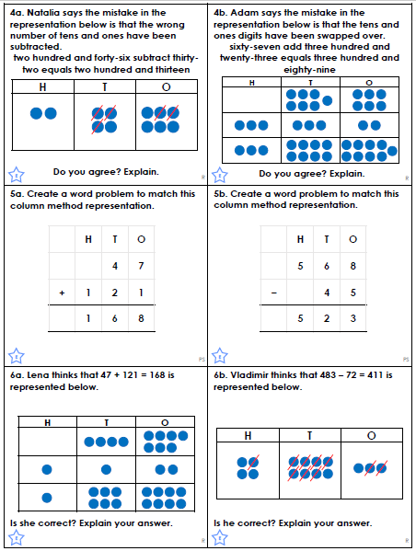
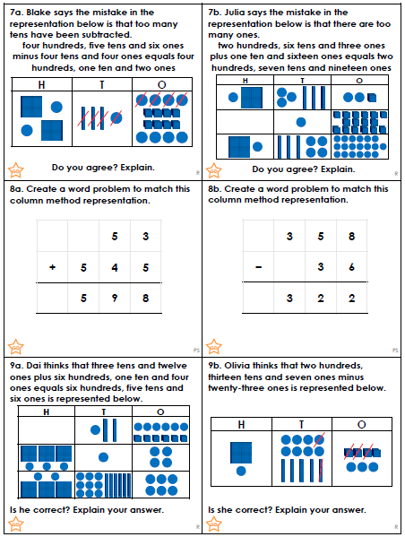

We have been looking at spellings from our assessments. Please add –ing to these words.
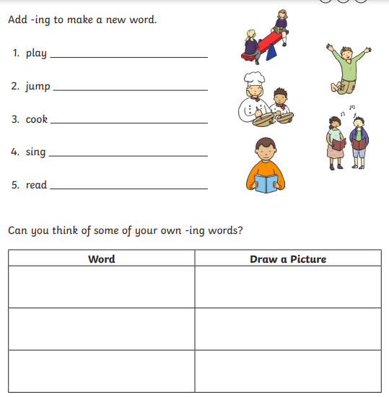

Challenge:
Add –er to the words.
1 | play
2 | jump
3 | cook
4 | sing
5 | read
We have been looking at our grammar assessments. We have been revising some aspects to consolidate our learning. Please go through this sheet and add the plurals.


