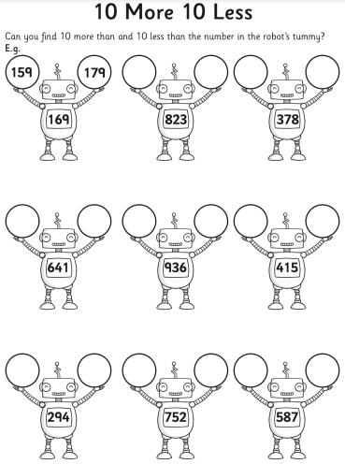

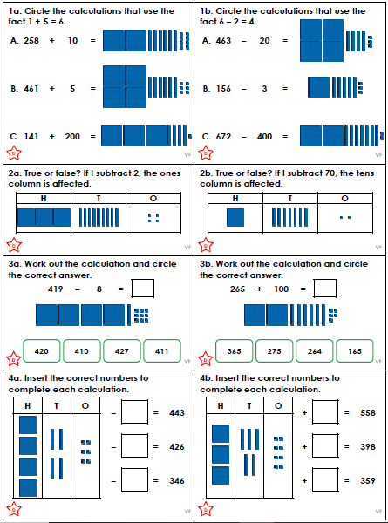
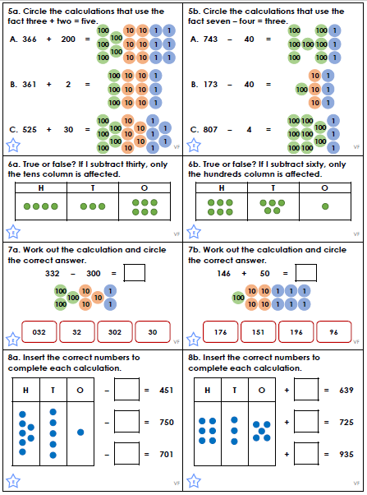
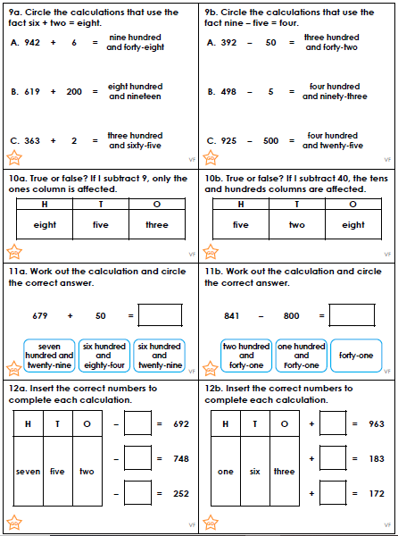
Correct the sentence punctuation:
Write the correct sentence underneath by adding in capital letters, full stops and question marks.

1 | my dog is red
2 | do you like sweets
3 | it is cold today
4 | is this your school
5 | the pen is green
6 | is that cat black
7 | he was sat on the wall
8 | I ate hot dogs from a box

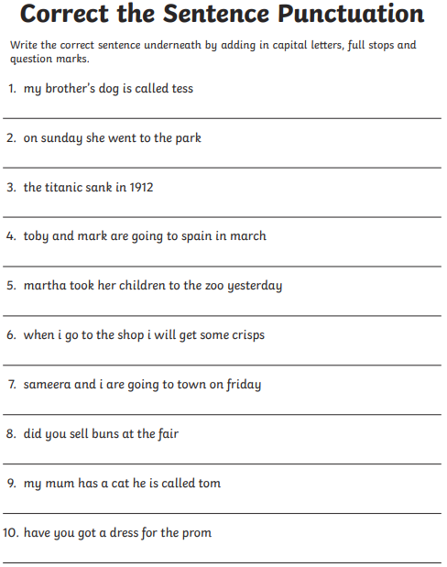

Homework – Year 3 – Set Friday 27th September, due Thursday 3rd October 2019



