Homework – Year 3 – Set Friday 30th September, due Thursday 6th October 2022

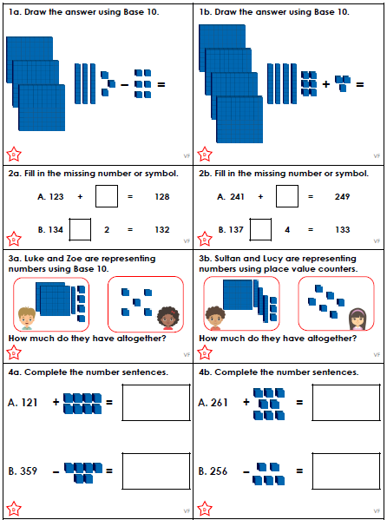

Homework – Year 3 – Set Friday 30th September, due Thursday 6th October 2022

Homework – Year 3 – Set Friday 30th September, due Thursday 6th October 2022

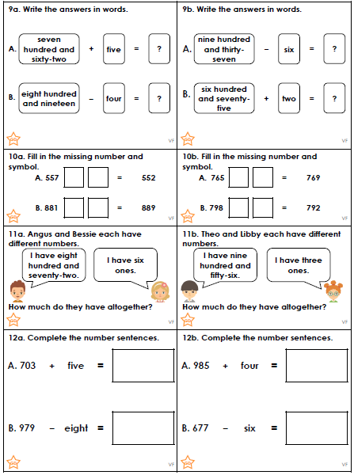
Homework – Year 3 – Set Friday 30th September, due Thursday 6th October 2022

Next Thursday is National Poetry Day.

We will be looking at animals so would like the children to think about this and write an acrostic poem. We have been looking at similes and personification in our poetry unit which links really well with this task.

