Year 3 Homework – Set Friday 23rd September, Due Thursday 29th September 2022

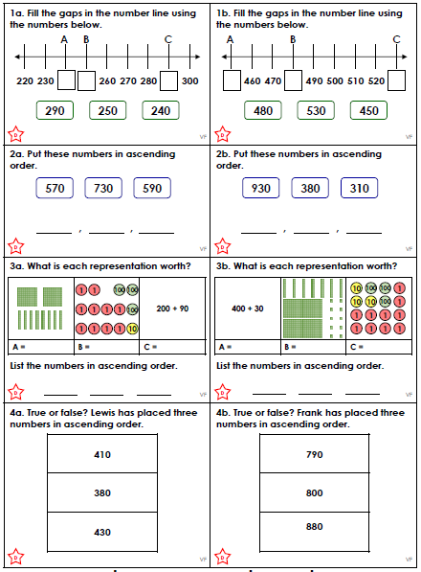

Year 3 Homework – Set Friday 23rd September, Due Thursday 29th September 2022

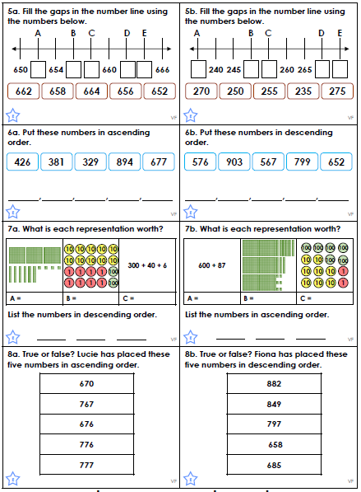
Year 3 Homework – Set Friday 23rd September, Due Thursday 29th September 2022

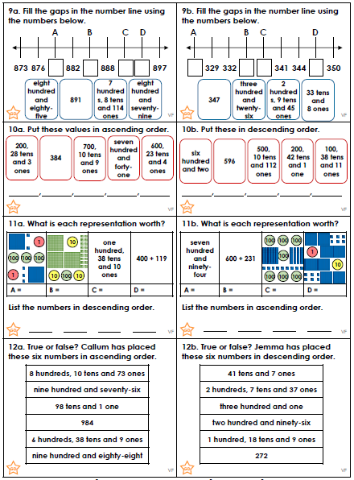
Year 3 Homework – Set Friday 23rd September, Due Thursday 29th September 2022

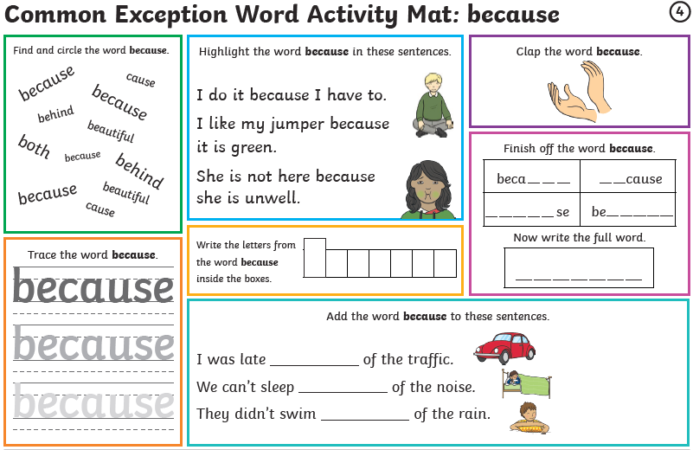
Year 3 Homework – Set Friday 23rd September, Due Thursday 29th September 2022



