Homework – Year 3 – Set Friday 16th September, Due 22nd September 2022
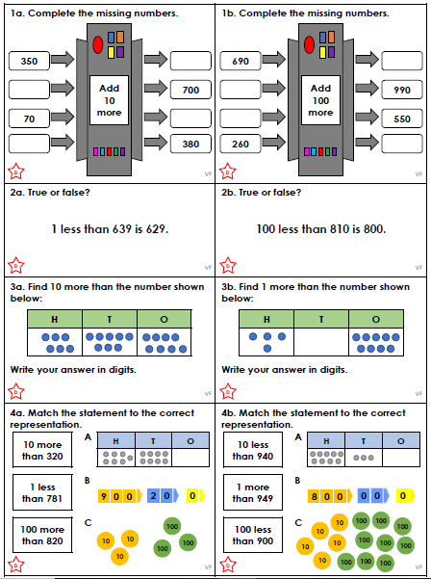

Homework – Year 3 – Set Friday 16th September, Due 22nd September 2022
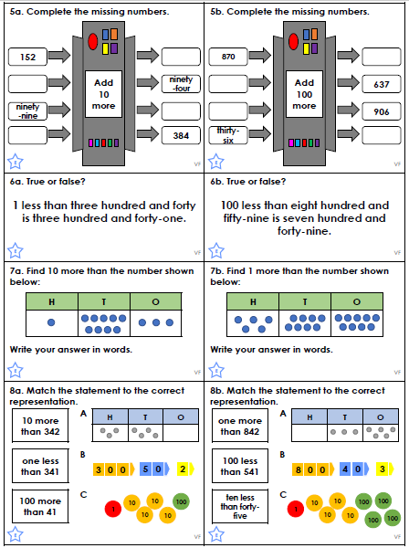

Homework – Year 3 – Set Friday 16th September, Due 22nd September 2022
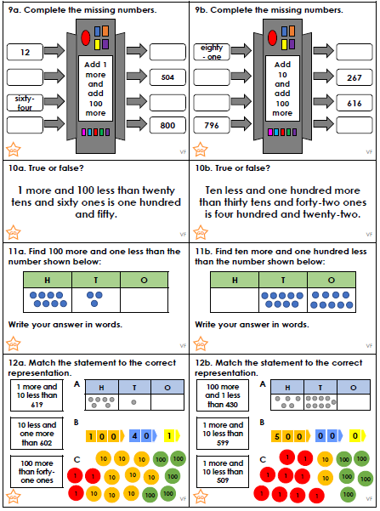

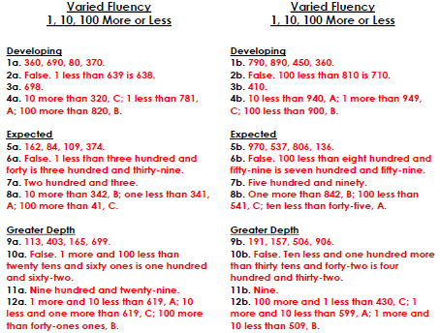

Homework – Year 3 – Set Friday 16th September, Due 22nd September 2022


