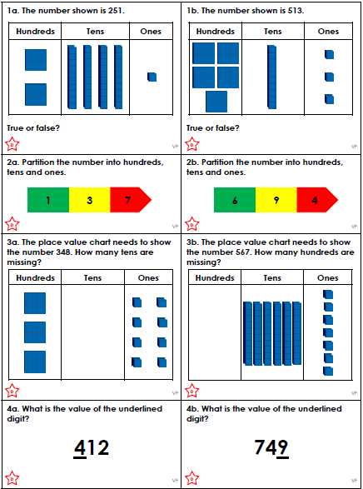
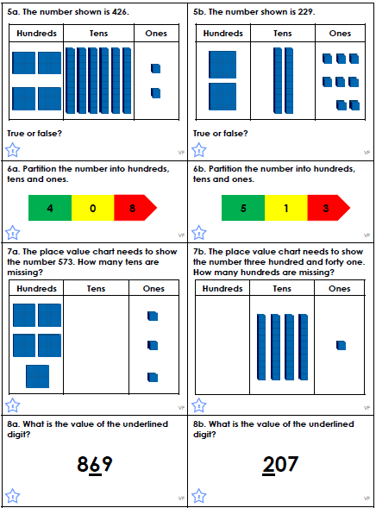
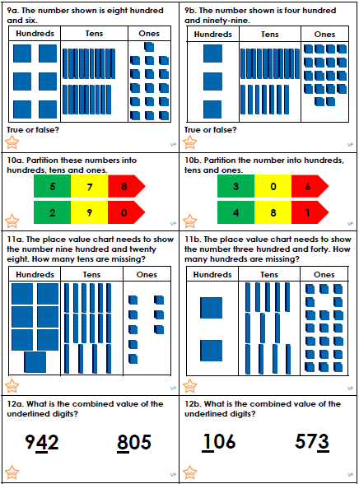

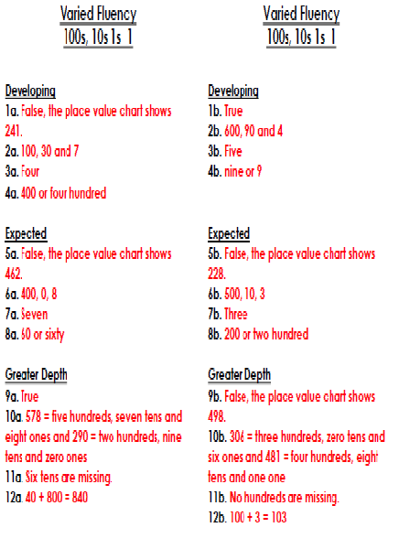

Within our English unit, we will be looking at imperative verbs to write instructions. So, what is a verb and what is its function? A verb can be defined as a doing or action word. It shows an action, event or state of being.

Each of these sentences has a verb missing. Can you guess what it is and write a sensible sentence using a verb of your choice underneath?

The girl ______ a goal.

A bird ______ up into a tree.

Yesterday, it ______ Tuesday.

The cow ______ the grass.

The man ______ the car.

Within our English unit, we will be looking at imperative verbs to write instructions. So, what is a verb and what is its function? A verb can be defined as a doing or action word. It shows an action, event or state of being.

Each of these sentences has a verb missing. Can you guess what it is and write a sensible sentence using a verb of your choice underneath?

The girl ______ a goal.

A bird ______ up into a tree.

Yesterday, it ______ Tuesday.

The cow ______ the grass.

The man ______ the car.

The sun ______ shining.

We ______ pictures of our faces

Within our English unit, we will be looking at imperative verbs to write instructions. So, what is a verb and what is its function? A verb can be defined as a doing or action word. It shows an action, event or state of being.

Each of these sentences has a verb missing. Can you guess what it is and write a sensible sentence using a verb of your choice underneath?

The girl ______ a goal.

A bird ______ up into a tree.

Yesterday, it ______ Tuesday.

The cow ______ the grass.

The sun ______ shining.

We ______ pictures of our faces.

The boy ______ into the swimming pool.

