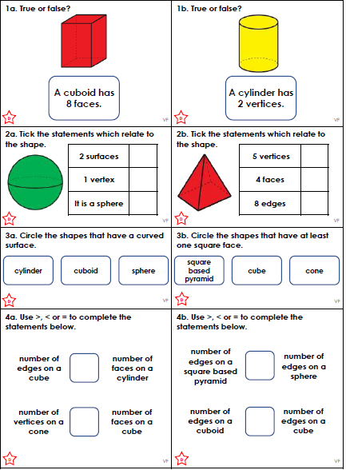

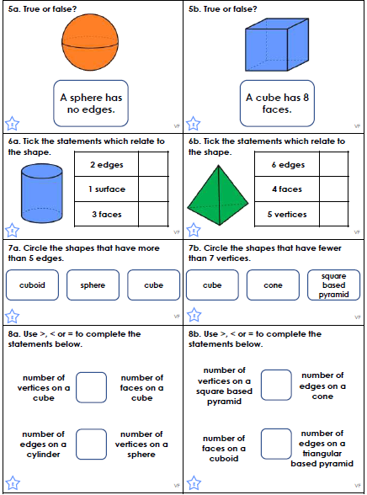

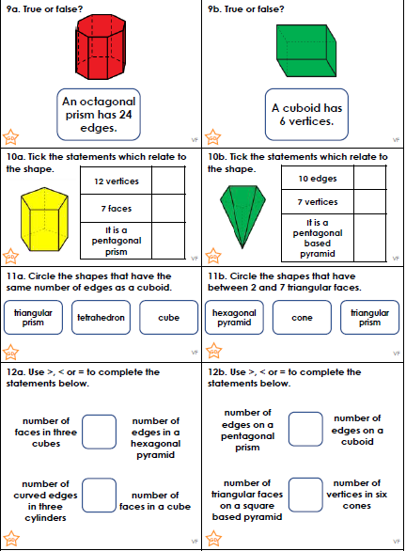

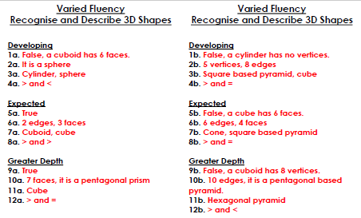
We have been looking at persuasion text in English. Please draw a picture of your house and advertise it for sale. What would make people buy it?
Don’t forget to use outrageous claims and exaggerate everything!
HOUSE FOR SALE
Seller:
Address:
Price:
Features inside:
Features outside:
These are the many reasons you should buy this house …

