Don’t forget that a vertical line is an upright one – like vertebrae keep us upright!
A horizontal always lies down getting his sleep zzzzzzzz …
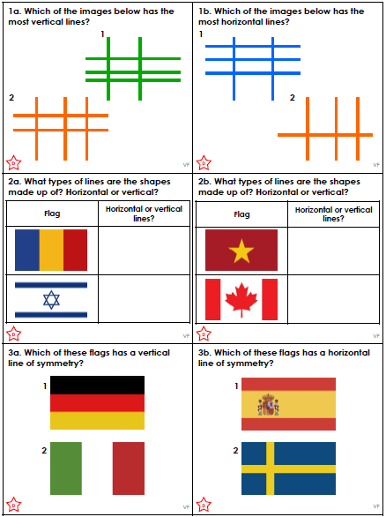
Don’t forget that a vertical line is an upright one – like vertebrae keep us upright!
A horizontal always lies down getting his sleep zzzzzzzz …

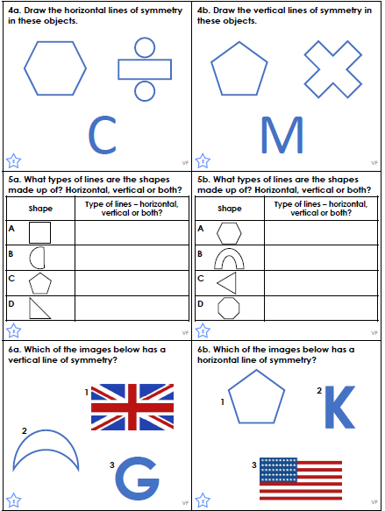
Don’t forget that a vertical line is an upright one – like vertebrae keep us upright!
A horizontal always lies down getting his sleep zzzzzzzz …
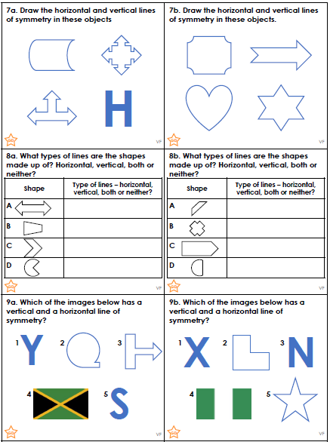
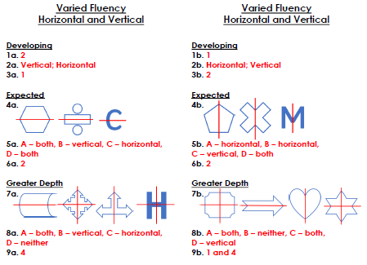

Rewrite the sentences so that the adverbial phrase is at the front, separate from the rest of the sentence with a comma.
She opened her present carefully.
Carefully, she opened her present.

Layla has an interview at the college on Friday.
On Friday, Layla has an interview at the college.

1 | The slimy slug crawled along the path very slowly.
2 | The teacher finished marking all of the homework eventually.
3 | The dog gobbled its food hungrily.
4 | Ella tiptoed down the stairs without making a sound.
5 | I am going to see the dentist this afternoon.
6 | Gilbert runs three miles every day.
Rewrite the sentences so that the adverbial phrase is at the front, separate from the rest of the sentence with a comma.
She opened her present carefully.
Carefully, she opened her present.

Layla has an interview at the college on Friday.
On Friday, Layla has an interview at the college.



