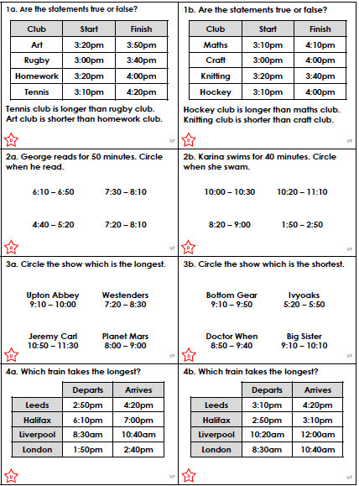

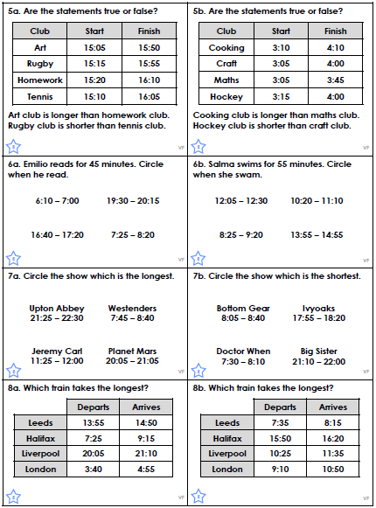

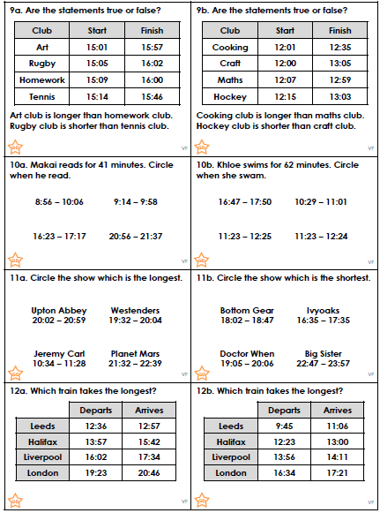

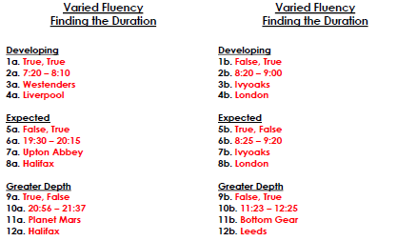
Can you spot the conjunctions in these sentences? Underline them all.
- I put on my shoes and I went out to play.
- I can’t eat my sweets until after dinner.
- I can’t go out tonight because I have to stay in and do my homework.
- It had been a long time since I had last played football.
- I was going to eat the sweets but I saved them for my sister.
- She was kind to me although she wouldn’t let me play with the Lego.

Coordinating conjunctions are remembered using the acronym FANBOYS.
Write a sentence for each word …

for
and
nor
but
or
yet
so

Can you spot the conjunctions in these sentences? Underline them all.
- I can’t eat my sweets until after dinner.
- I can’t go out tonight because I have to stay in and do my homework.
- It had been a long time since I had last played football.
- She was kind to me although she wouldn’t let me play with the Lego.

Subordinating conjunctions are remembered using the acronym ISAWABUB. Write a sentence for each word.

if
since
as
when
although
while
after
before
until
because

