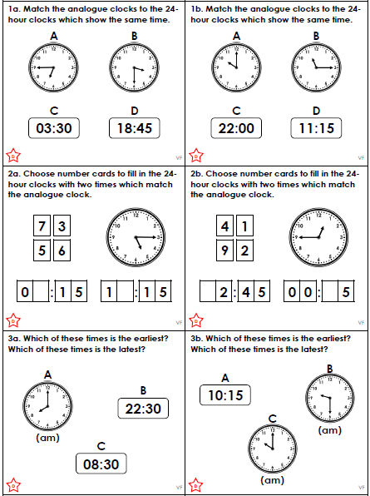

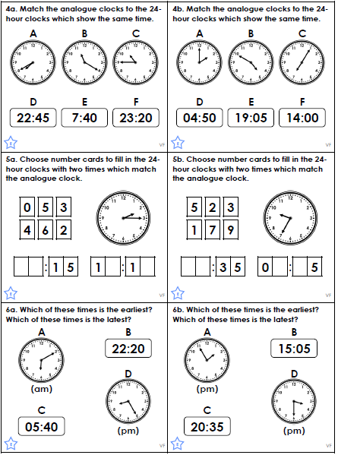

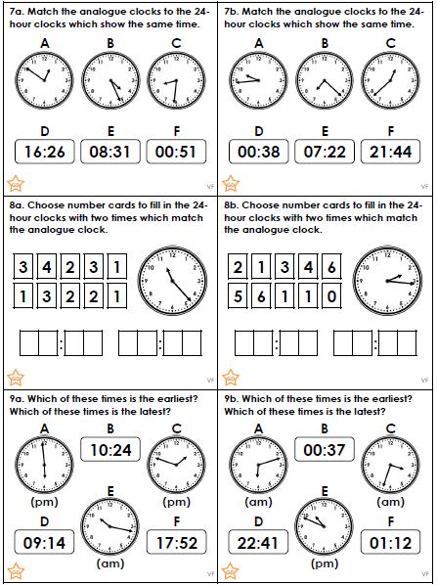
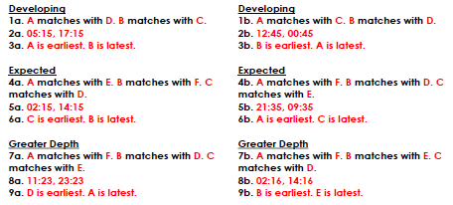

We have been learning World Ocean Day. Please write an explanation text about the benefits of World Ocean Day and how we can make things better for the ocean.
- Why Is the Ocean So Important?
- Oceans At Risk
- Plastic Pollution
- Climate Changes
- What can we do?
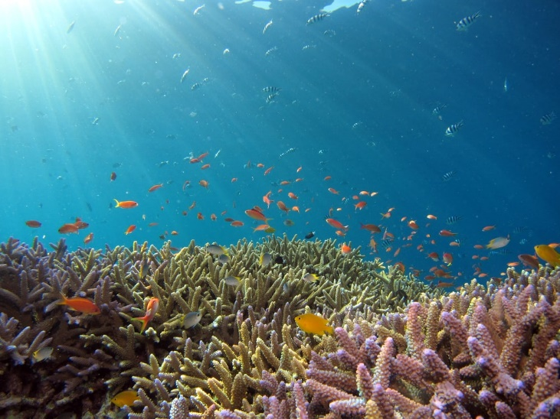
Why is the ocean so important?

