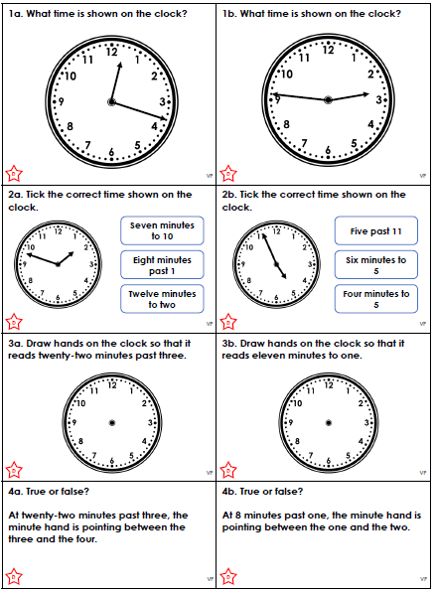

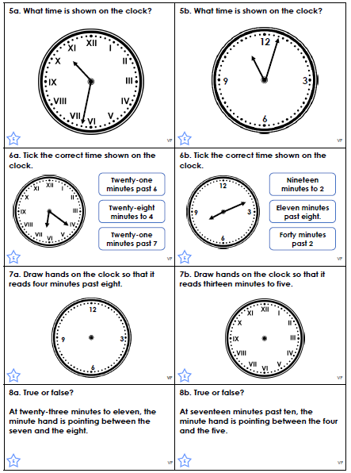

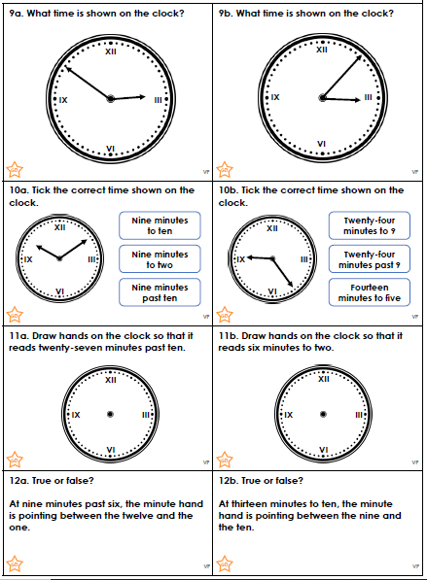
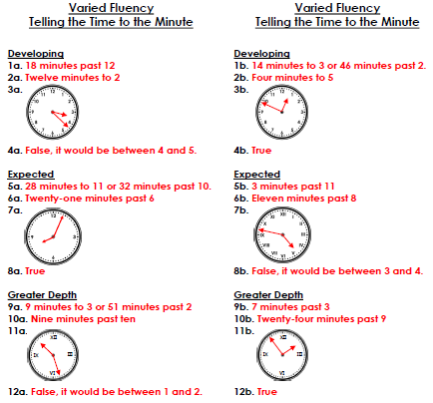

Write a letter to the Queen!
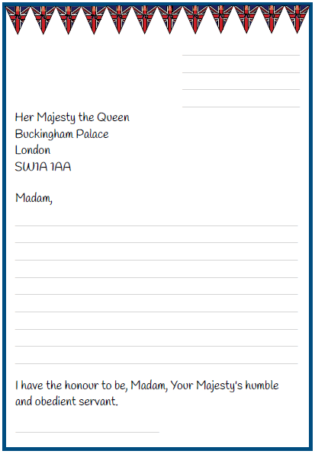
You might want to include: congratulations on celebrating 70 years of service some information about yourself (how you are going to celebrate the Platinum Jubilee) and some questions for the Queen - what would you like to ask her?
Write a letter to the Queen!
You might want to include: congratulations on celebrating 70 years of service some information about yourself (how you are going to celebrate the Platinum Jubilee) and some questions for the Queen - what would you like to ask her?


