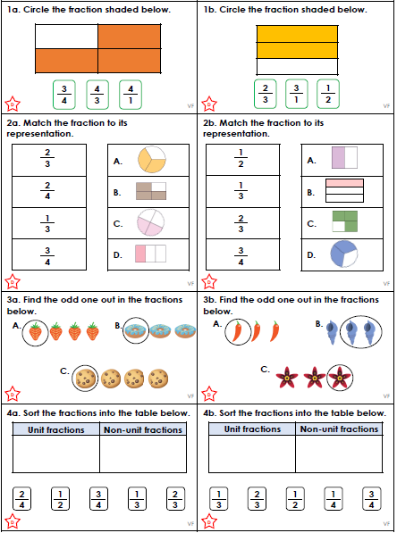

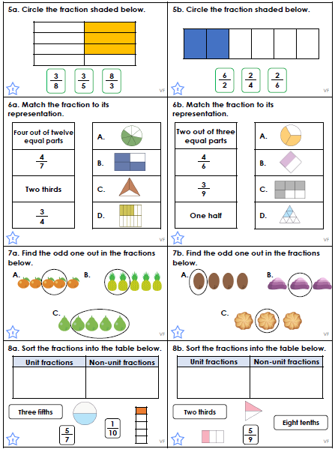

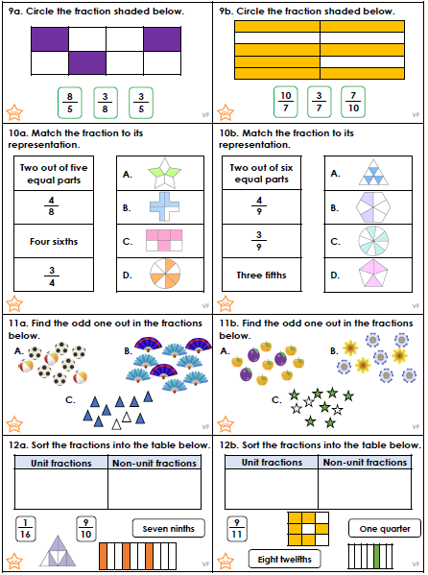

We have been learning about homophones and their different spellings. Homophones are words that sound the same but are spelt differently and have different meanings.

Pick five boxes and write definitions for each word in the pairing:
beach/beech | blue/blew | board/bored | bread/bred | current/currant
dear/deer | flour/flower | guest/guessed | hair/hare | horse/hoarse
loan/lone | made/maid | missed/mist | more/moor | pail/pale
pane/pain | pair/pear | pause/paws | rose/rows | seam/seem

1
2
3
4

Write homophones for these words:
a) | banned |  | b) | bawl |  | c) | lessen
d) | tail |  | e) | write |  | f) | source
g) | grate |  | h) | read |  | i) | would

We have been learning about homophones and their different spellings. Homophones are words that sound the same but are spelt differently and have different meanings.

Pick five boxes and write definitions for each word in the pairing:
beach/beech | blue/blew | board/bored | bread/bred | current/currant
dear/deer | flour/flower | guest/guessed | hair/hare | horse/hoarse
loan/lone | made/maid | missed/mist | more/moor | pail/pale
pane/pain | pair/pear | pause/paws | rose/rows | seam/seem

1
2
3
4

Write homophones for these words:
a) | banned |  | b) | bawl |  | c) | lessen
d) | tail |  | e) | write |  | f) | source
g) | grate |  | h) | read |  | i) | would

Chose the right spellings for these gaps:
In the ____________________ in the traffic, he pressed on the ____________________ (brake/break)
It is only ____________________ that you pay the right ____________________ (fair/fare)
If you give us some ____________________, I’ll give you a ____________________ of cake. (piece/peace)
When she was ____________________, she ____________________ lots of sweets. (ate/eight)



