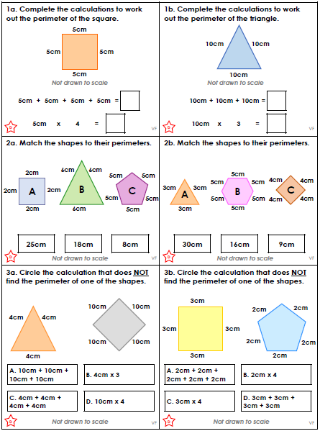

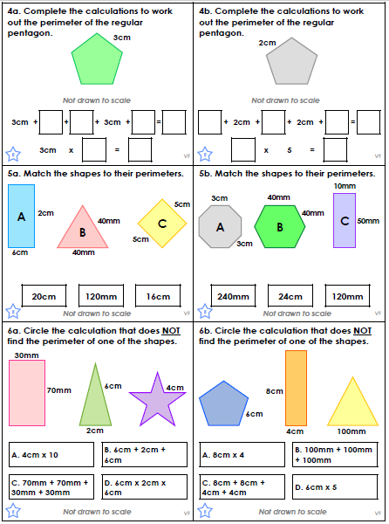

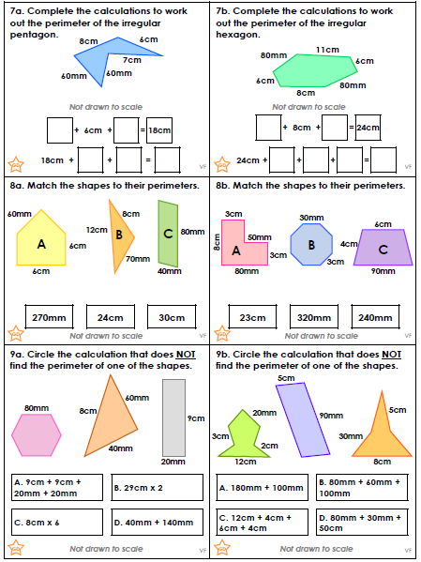

We have been learning to write in present tense for our non-chronological reports.

A good way of understanding verbs is to think of them as action or doing words. They show what someone or something is doing.

All the action words in these sentences are showing what someone or something is doing now. We call this the “present tense”. We often add “am”, “is” or “are” in front of the verb.

Circle the action words below. Include “am”, “is” or “are” as part of the verb.

- We are watching the football on the TV.
- I am playing with my super new game.
- The phone is ringing in the kitchen.
We also use verbs in the present tense for things that happen often or all the time.

Circle the verbs below:

- Grandad digs the garden every day.
- Granny works in the charity shop.
- The ducks swim in the local lake.
- Every week Sam buys a computer magazine from the shop.
Write a sentence for each of these present tense verbs:
is running | writes | is driving | eats

We have been learning to write in present tense for our non-chronological reports.

A good way of understanding verbs is to think of them as action or doing words. They show what someone or something is doing.

All the action words in these sentences are showing what someone or something is doing now. We call this the “present tense”. We often add “am”, “is” or “are” in front of the verb.

Circle the action words below. Include “am”, “is” or “are” as part of the verb.

- The taps in the bathroom are leaking.
- The happy child is playing in the park.
- I am sailing my boat out of the harbour.
We also use verbs in the present tense for things that happen often or all the time.

Circle the verbs below:

- The blackbird sings in the garden every day.
- The children always work hard in Parkfield Primary School.
- Every day I drive my car to school.
- I write the date and learning objective at the top of my page every day.
Write a sentence for each of these present tense verbs:
is walking | find | am singing | drink | are hoping



