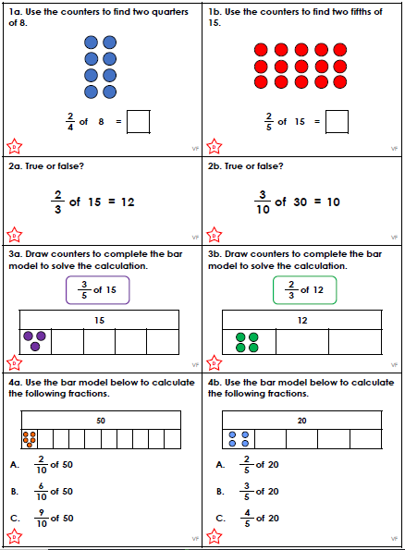

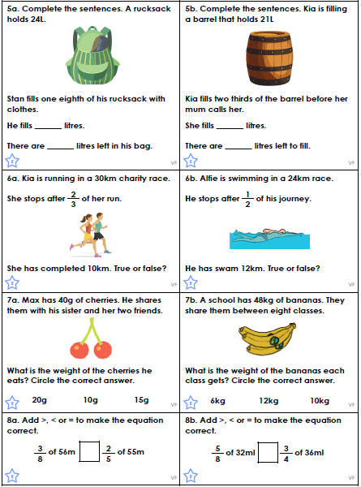

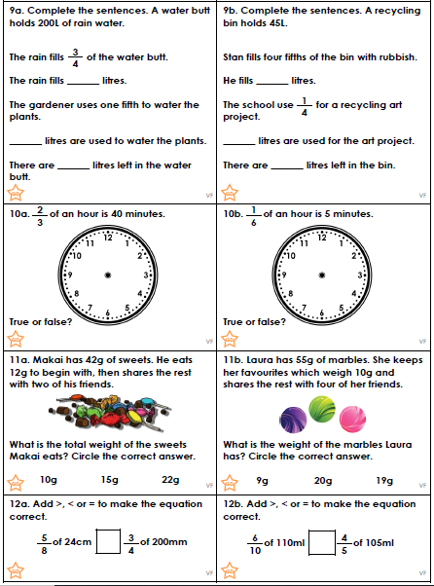

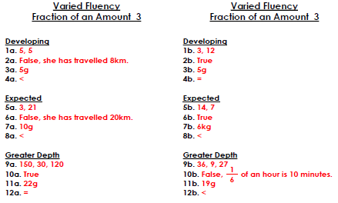
Next term, we will be looking at story writing. In preparation for this, please use a thesaurus to change the underlined words for more interesting words.

One nice _______________ day last summer, Katy decided to walk _______________ to the park. She said _______________ to Sarah “Would you like to come too?”
“Oh yes please,” said _______________ Sarah happily _______________.
The two friends had a good _______________ chat on the way to the nice _______________ park about their summer. They were both happy _______________ that the weather was so lovely _______________.

When they got to _______________ the park, the girls were happy _______________ to find that they had the playground to themselves. They walked _______________ to the swings and started to play. After a while, Katy said _______________ that they should go and buy some lollies. They were nice _______________. When they had finished eating _______________ their lollies, the girls walked _______________ back to their home along the quiet _______________ street.

Next term, we will be looking at story writing. In preparation for this, please use a thesaurus to change the underlined words for more interesting words.

One nice _______________ day last summer, Katy decided to walk to the park. She said _______________ to Sarah “Would you like to come too?”
“Oh yes please,” said _______________ Sarah.
The two friends had a good _______________ chat on the way to the park about their summer. They were both happy _______________ that the weather was so lovely _______________.

When they got to _______________ the park, the girls were happy _______________ to find that they had the playground to themselves. They walked _______________ to the swings and started to play. After a while, Katy said _______________ that they should go and buy some lollies. They were nice _______________. When they had finished, the girls walked _______________ home.

