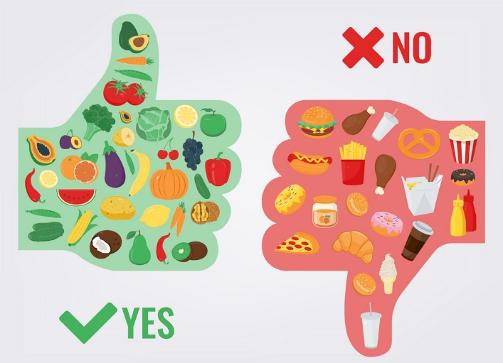

We are what we eat …
Homework Menu - Summer Term 2
Due: Friday 11th July 2025
Please email photographs of your work/presentations or bring your work in to share with everyone on the decking.
We would love to celebrate your hard work.

English:  Write out your favourite recipe.  Write an explanation about the benefits of a healthy lifestyle. | Computing:  Research ten vegetables which can be grown in the British climate and explain when they should be planted and harvested. |  | Geography  Research where bananas are grown and work out how far they travel to our supermarket. Record your findings on a world map.
Science/ Maths:  Find out how many bones different animals have and compare them to humans.  Why might different animals have differing amounts of bones? |  | 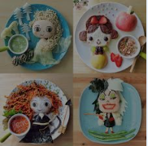  Art:  Design a piece of art using food as a medium.
D&T:  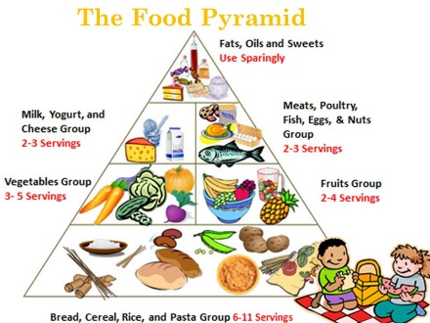  Design and cook a healthy, balanced meal for your family.  Think about what it would need to include. |  | SCHOOL VALUE - COURAGE    Explain what courage is and why it is an important value to have.  How has it helped you or  someone you know?

