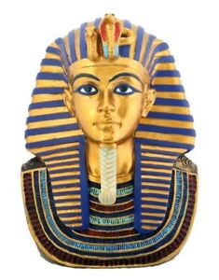
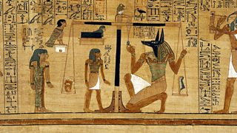
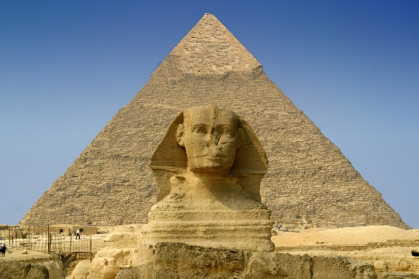
Walk Like an Egyptian
Homework Menu - Summer Term 1
Due: Friday 16th May 2025
Please email photographs of your work/presentations or bring your work in to share with everyone on the decking.
We would love to celebrate your hard work.

ART  Research ideas and create another headdress for Tutankhamun.  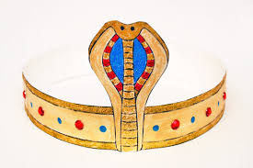  This links to the Rights of the Child Article 31 ‘You have the right to rest, play and take part in artistic activities. |  | MATHS  The ancient Egyptians were said to make right-angled triangles using a rope which was knotted to make 12 equal sections.  If you have a rope knotted like this, what other triangles can you make? (You must have a knot at each corner.) What regular shapes can you make?  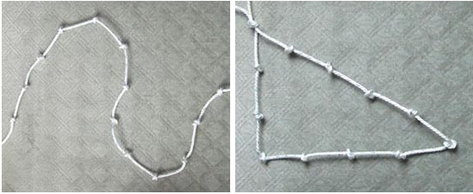 |  | ENGLISH  Write a persuasive leaflet encouraging people to visit to visit the pyramids of Ancient Egypt.  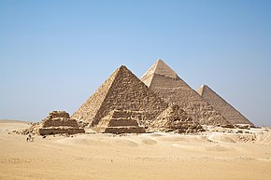
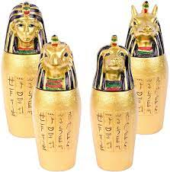  DT  Design and make an Ancient Egyptian Canopic jar using materials of your choice. | INTERNET SAFETY  Explain which apps, games and websites are appropriate for a child of my age?  Give examples.  Draw a poster demonstrating this. |  | PSHE  Eat something you’ve not tried before! Take a photo of the food and your face before and after you have tried it.  Our tastes in food can change as we get older, so there is always an opportunity to try something again too! |  | SCHOOL VALUE  HONESTY  Write a short play script demonstrating the importance of being honest.  

