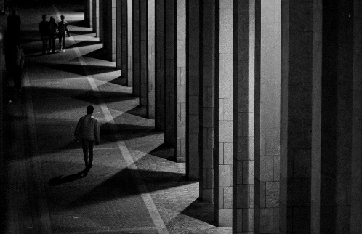
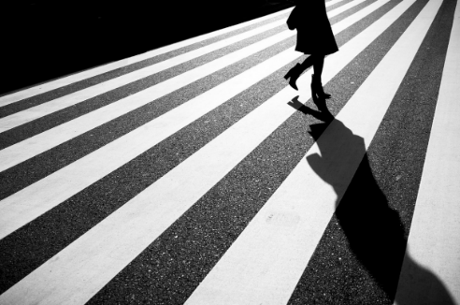
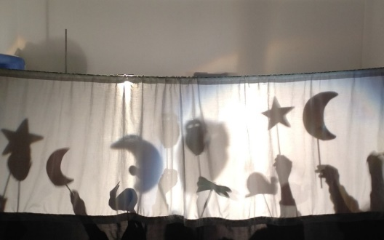
Light and Shadow
Homework Menu - Spring Term 2
Due: Friday 28th March 2025
Please email photographs of your work/presentations or bring your work in to share with everyone on the decking.
We would love to celebrate your hard work.
activities.

MATHS/SCIENCE  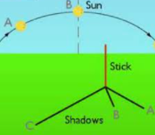  Place a pole or object in a sunny place. Measure the length of the shadow on the ground every hour for 6-8 hours. Record your findings in a table. | ART/DT  (My Activity Passport)  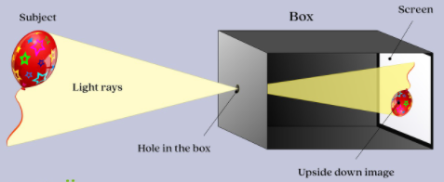  Make a pinhole camera.  Draw and label your design.  Explain what it does. | MUSIC  (My Activity Passport)    Design a piece of music which would be suitable for spring.  Send in a recording of yourself performing it!
ENGLISH  Research and then write an explanation text on how shadows are formed.  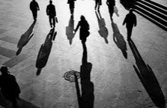    Design a pair of sunglasses or a hat which will keep you safe from the sun’s harmful rays.  Explain why it is important to protect yourself from the sun. | VALUES - FORGIVENESS  Daisies are the flower of forgiveness.  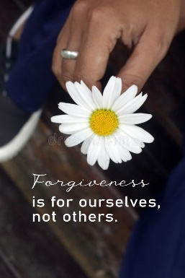  Create a poster showing the importance of forgiveness and situations where forgiveness is needed.  Remember to include daisies. | COMPUTING  Have a go at one of the lessons  here …    Take a photo of yourself programming!  https://turtleacademy.com//lessons  E-SAFETY  Explain how to a trusted adult how my and other people’s feelings can be hurt by what is said or written online.  Write a list of rules to follow explaining how you should behave online.

