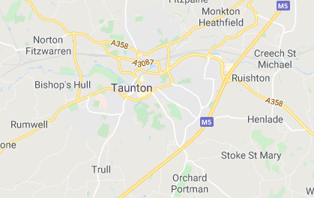
Where in the world am I?
Homework Menu
Spring Term 1
Due: Friday 7th February 2025

Please email photographs of your work/presentations or bring your work in to share with everyone on the decking.
We would love to celebrate your hard work.

COMPUTING  Computational Thinking  Draw a simple flow-chart with simple step instructions on how to dress for the weather outside. | MATHS  We will be learning about money and adding or subtracting money to give change.  Go to the shop and buy a couple of items. Add up their total price and calculate what change you will receive with the money you hand over.  Bring a photo or your calculations to show others. |  |  | GEOGRAPHY  Draw a map of your house or garden. You should include a key and the eight compass points.
DT/ PSHE  (My Activity Passport)  Try some yoga for mindfulness. See the website below for inspiration.  https://www.cosmickids.com/mindfulness-meditation-videos-kids/ |  | E-SAFETY  Explain to your trusted adult why copying someone else’s work from the internet without permission can cause problems. Create a short cartoon strip of what those problems might be. | SCHOOL VALUE: RESPECT UNICEF’s Rights of the Child Article 14  Draw a picture of someone you respect or is a good role model to you. In full sentences, explain why you respect them and how you can both be respectful to each other and what you believe.

