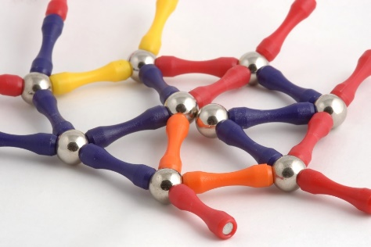
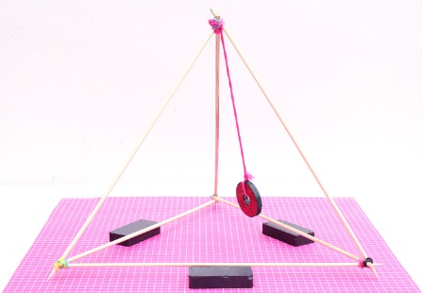
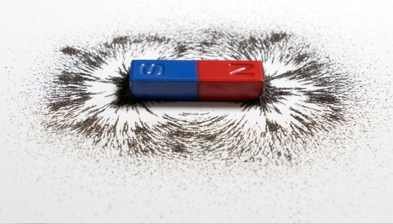
What’s the attraction?
Homework Menu
Autumn Term 2
Due: Friday 13th December 2024
Please email photographs of your work or your presentations or bring your work in to share with everyone on the decking.
We would love to celebrate your hard work.

DT/ PSHE  (My Activity Passport)  Design and make a board game that uses magnets.  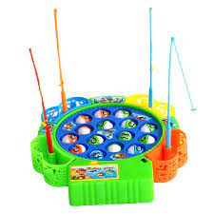  (e.g magnetic fishing rods) | MATHS/ SCIENCE  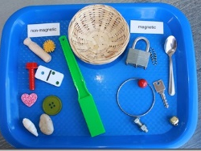  Gather a selection of household items.  Predict, then test whether these objects will be attracted to a magnet. Present your findings in a table.  (e.g. scissors, paper clips, pencil, pens, marble, stapler, saucepan, different coins, and your own ideas) | ENGLISH  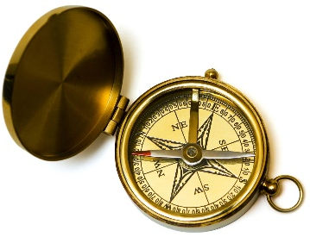  Research and create a chronological report on the history of the magnetic compass.
E-SAFETY  Design a poster outlining rules about how to behave online and how you follow them. | COMPUTING  Make a PowerPoint presentation to show how magnets are used in everyday life and include images.  (e.g. in hospitals, in technology, in scrap yards, for jewellery) | SCHOOL VALUE:  FRIENDSHIP  Draw a cartoon strip of a situation where somebody showed kindness and friendship in a tricky situation.

