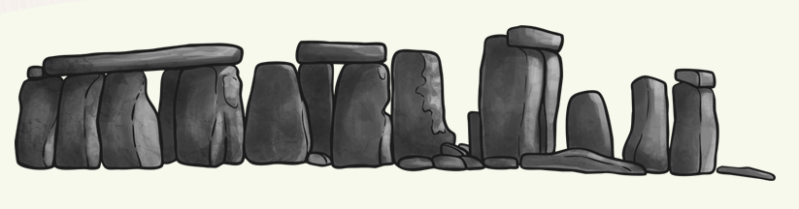
Set in Stone
Homework Menu
Autumn Term 1
Due: Friday 18th October 2024
Please bring your work in to share with everyone on the decking.
We would love to celebrate your hard work.
SCIENCE:  Go on a rock hunt!  Can you find any fossils?  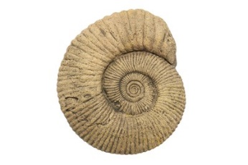  How many different ways can you sort the rocks you collect? | INTERNET SAFETY:  Design a poster to explain why you should be careful before you share anything about yourself or others online, and then who you should ask if you are not sure if you should put something online. | HISTORY:  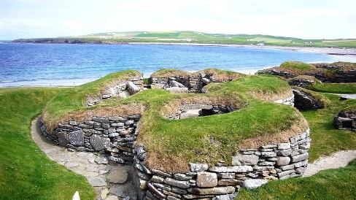  Research ten facts about Skara Brae. Present your facts either in a poster or a PowerPoint.
SCHOOL VALUES:  RESILIENCE  Using any resources you like, draw or make a time when you have shown resilience. Then write how you could have been resilient at a time when you found something challenging.   | D&T:  Create a Stone Age, Bronze Age or Iron Age village using anything you wish!  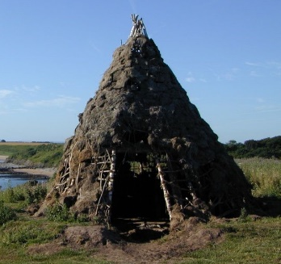  For example, you could bake, use Lego or Minecraft etc. | MATHS:  Create an edible rock such as a rock cake. Produce a recipe stating what each ingredient represents  For example, currants could represent Quartz and chocolate chips could represent feldspar in granite.  
ACTIVITY PASSPORT:
Produce rubbings of fossils.

