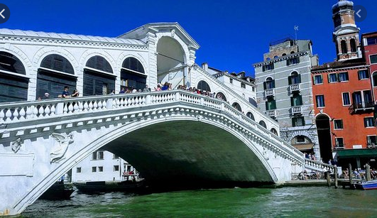
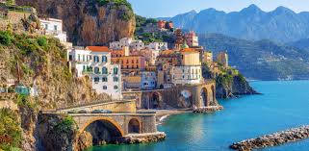
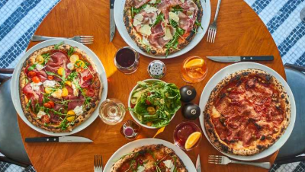

Please complete at least two of the above activities by Monday 9th February 2026
If you are going to bring in any models to show the class, please bring them in on this date.

DT  Using any materials you like, create a London Landmark (Big Ben, Tower Bridge, London Eye)  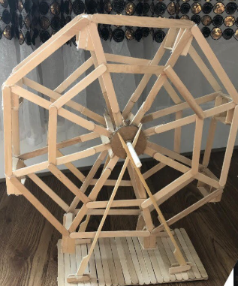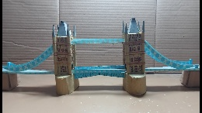 | 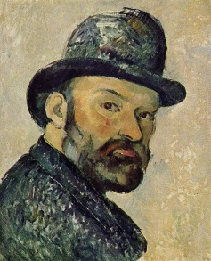  Art:  Draw a portrait in the style of Romero Britto using whatever medium (crayon, paint, natural materials) you wish. | Maths:  Design a survey to find out what your friends and family’s favourite Italian food is and present your data  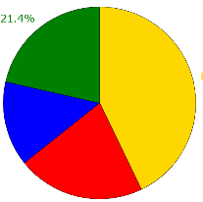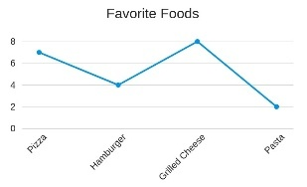
Geography/Computing:  Research key landmarks in Italy, London and Taunton!  Use either word or PowerPoint to present your information. | Captivating Campania Spring Term 1 | Online Safety:  You can find out a lot about people by searching online.  Explain how you can make sure your information is kept safe and private.
Activity Passport:  Take a walk through a forest or woodland.  Fina a range of Human or Physical features. | Values – Respect  Our value for this half term is respect. This links to the Rights of the Child Article 12 (respect the views of the child)  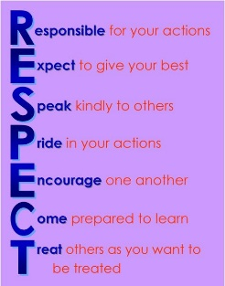  Write an acrostic poem showing how to be respectful. | Science:  Find a range of materials and sort them into conductors and insulators ( rubber band, foil, spoon, wood etc)  

