Year 3 homework due back on Thursday 20th November

1. Fill in the blanks with paired conjunctions (both,and)

a) I like ______ apples ______ oranges.

b) We saw ______ cats ______ dogs at the park.

c) She can play ______ the piano ______ the guitar.

d) We need ______ paper ______ pencils for the project.

e) He is ______ kind ______ helpful to everyone.

2. Can you write 3 of your own paired conjunction sentences.

3. Which sentence is written in the simple present tense?
a) She play football every day.
b) She plays football every day.
c) She playing football every day.
a) Birds fly in the sky.
b) Birds flies in the sky.
c) Birds flying in the sky.
a) He go to school by bus.
b) He goes to school by bus.
c) He going to school by bus.
4. Fill in the blanks with a subordinating conjunction.
a) I stayed inside ________ it was raining.
b) We will go to the park _________ the sun comes out.
5. Write your own sentence including a subordinating conjunction.

- Complete these addition subtractions remember you are bridging 100.
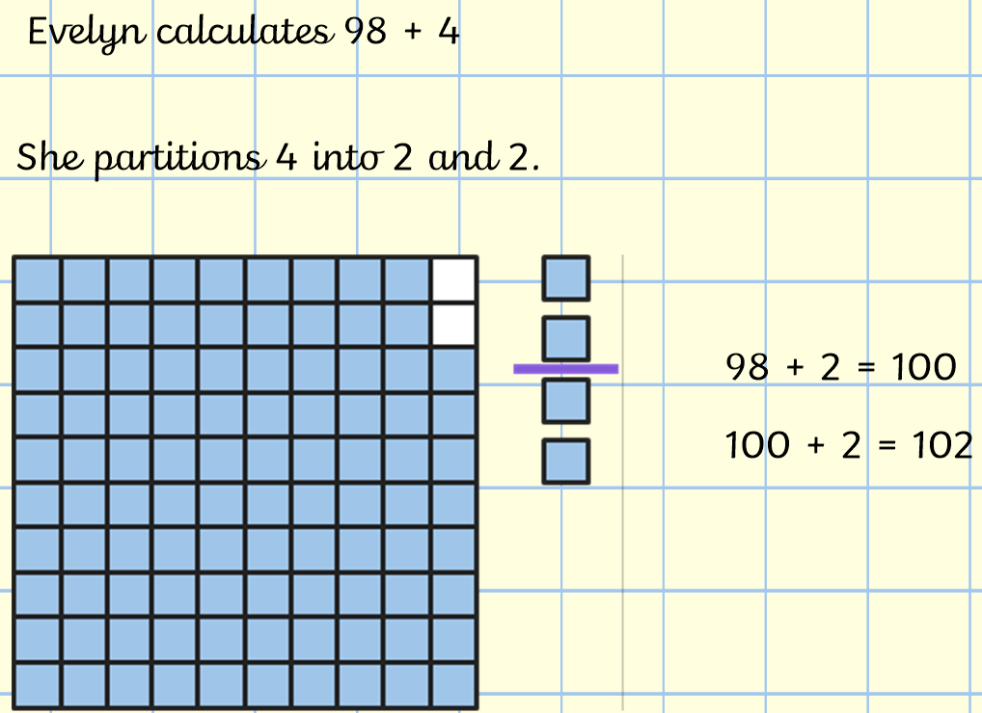

a) 85 + 7 = b) 88 + 9 = c) 91 + 7 = d) 93 + 1 = e) 99 + 9 =

