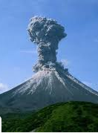
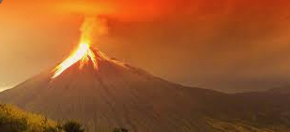
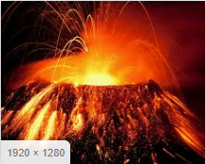

Please complete at least two of the activities from the menu below and hand in by Friday 12th December

DT/Geography:  Create a 3D volcano. You could use cardboard, paper mâché etc  Ext: Label it  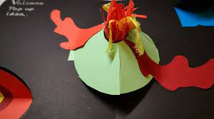 | Online Safety:  Create a poster or leaflet explaining what cyber bullying is, how to stay safe online and what to do if it happened to you.  You may wish to look at the NSPCC website for ideas. | Maths  Create your own multiplication game to play with a parent or sibling.  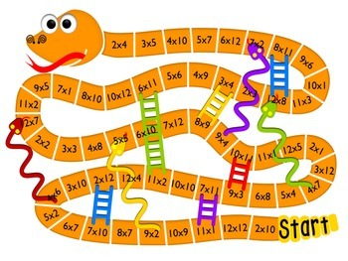
Art  Use a crayon to make a range of rubbings.  Experiment by placing the item under the paper and rub the crayon over the top.  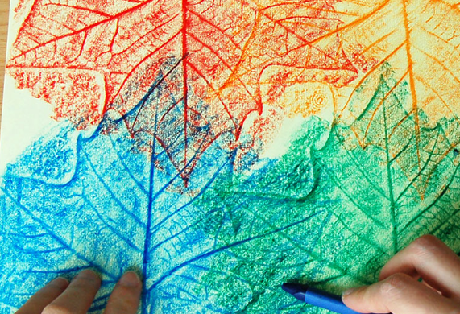 | ‘Escape from Pompeii’  Autumn 2  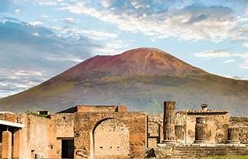 | Rights Respecting School  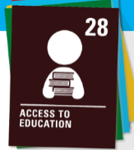  Write a speech about why you think every country in the world should up hold Article 28 - Every child has a right to education and it should be free.
Activity Passport:  Learn to sew on a button!  Photograph your achievement and send it to us!  Perhaps you could write some instructions to teach someone else how to do it? | Values – Friendship  Article 31 – We have the right to relax and play  Write a poem about friendship. It could be based on the ‘Recipe for friendship’ we looked at in class or it could be an acrostic or any style you wish. | Science  Take pictures or draw images of solids, liquids and gases in your house or area.  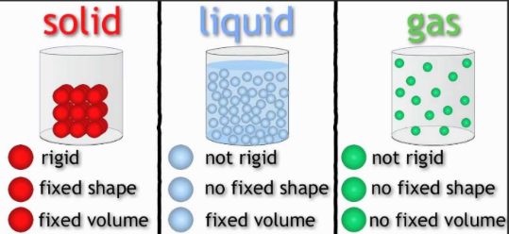
Extension – Find out 5 interesting facts about the eruption of Mount Vesuvius in 79 AD.

