Year 3 homework due back in Thursday 2nd October
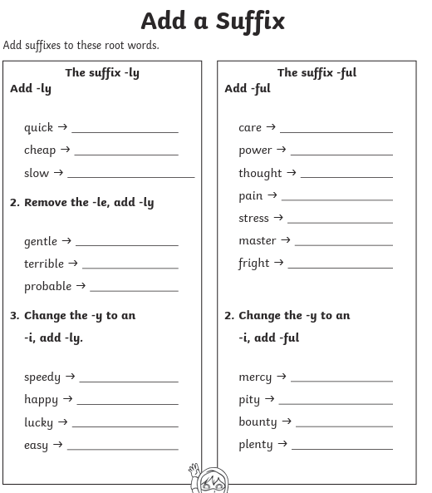
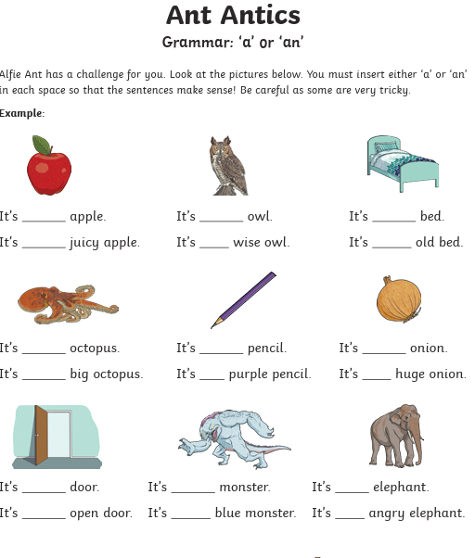
If the word starts with a vowel a,e,i,o,u it is an. If it a consonant it’s a.


