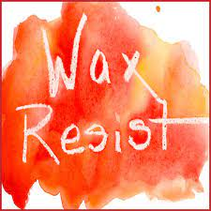
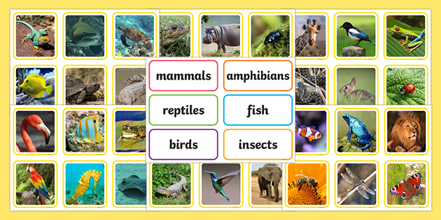
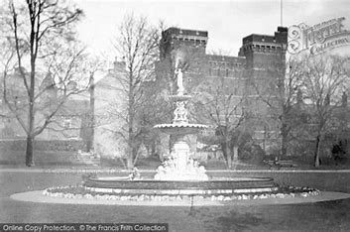

Art:  Can you create a wax resist picture using wax crayon and a colour wash?  Please ask if you need to borrow and materials for this. | History  Our History topic is  ‘How has our local park changed? If you can, visit  Vivary Park and  write three interesting facts about it. Perhaps you could include photos too! | Science: Animals including humans  Research and create a poster about how we can keep ourselves healthy.  
Maths:  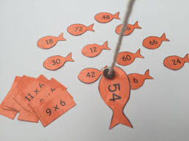  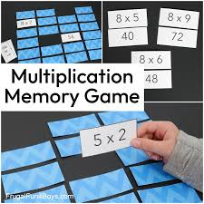  Design a simple game to help you learn either the 10, 5 or 2 times table. | Exploring Our World  Year 2 – Autumn 1  2025 | Rights Respecting School  Article 31 – the right for play, leisure and culture.  Visit a famous landmark, take a photograph and write about why it is famous.  This could be Wellington Monument!
Activity Passport:  Play a board game!  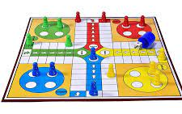 | School Value:  Resilience  Draw a picture showing a time when you were showing resilience and add a speech bubble. | Online Safety:  Explain why you need to ask a trusted adult before playing a game on the internet  

Bring into school or email before the final week of the half term.

Please complete a minimum of two tasks

